Name: _________________________________ Hour: __________ Date: __________________

Cell Transport Reading and Questions

The Cell Membrane
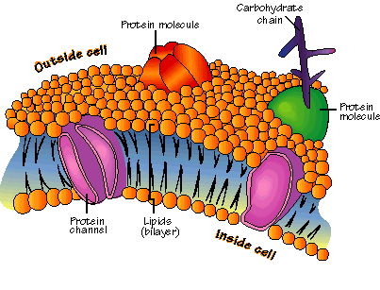
The job of the cell membrane is to regulate what enters and exits the cell. The cell membrane acts in a way that is similar to the doors and windows of your house. Since some “stuff” can come in and some “stuff” must stay out, the cell membrane is said to be selectively permeable. The cell membrane regulates what enters and leaves the cell and also provides protection and support.

Nearly all cell membranes are made of a doubled layered sheet called a phospholipid lipid bilayer. The bilayer gives the cell membrane a tough flexible structure that forms a strong barrier between the cell and its surroundings.

The cell membrane is made of three major molecules; lipids, proteins, and carbohydrates. The lipids are what forms main part of the membrane around the cell. The proteins are scattered throughout the cell membrane and form channels or pumps to help move materials across the membrane. The carbohydrates are attached to the outside of the cell membrane and act like chemical identification cards, allowing cells to identify one another.

Homeostasis
All living things, from single cells to entire organisms, have mechanisms that allow them to maintain stable internal conditions. Without these mechanisms, organisms can die. For example, a cell’s water content is closely controlled by taking in or releasing of water. A cell that takes in too much water will rupture and die. A cell that doesn’t get enough water will shrivel and die.

Homeostasis is the maintenance of a stable level of internal conditions even though environmental conditions are constantly changing. Organisms have regulatory systems that maintain internal conditions, such as temperature, water content, and uptake of nutrients by the cell. In fact, multicellular organisms usually have more than one way of maintaining important aspects of their internal environment. For example, an owl’s temperature is maintained at about 40°C (104°F). To keep a constant temperature, an owl’s cells burn fuel to produce body heat. In addition, an owl’s feathers can fluff up in cold weather. In this way, they trap an insulating layer of air next to the bird’s body to maintain its body temperature.

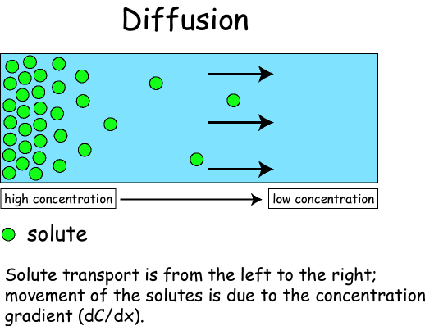
Passive Transport
The cell membrane plays a very important role in maintaining a cell’s homeostasis. Small molecules and molecules that do not have a charge can easily pass through the cell membrane without any energy required by the cell. This type of movement, when no energy is required, is called Passive Transport.

Passive Transport is when molecules that are in a high concentration area (crowded area) move to a lower concentration area (less crowded area). Molecules will always move to areas where it is less crowded for them, without any energy needed. This movement of molecules from a high concentration area to a low concentration area is called “moving down the concentration gradient”. If you think about it, don’t all things move “down” without any energy required?

There are 3 types of passive transport that you will have to know – Diffusion, Osmosis and Facilitated Diffusion. Remember that all 3 are passive transport – no energy required, all movement is from high concentration to low concentration! Diffusion is when any molecule moves from high to low concentration. Osmosis is when water moves from high to low concentration. Facilitated Diffusion is when large or charged molecules move through a channel protein in the cell membrane. The channel protein is similar to a “doggie door” in your house – it is just the right size hole for your dog to enter or exit without any energy required by you!

Since molecules will always move from high to low concentrations, living things use this mechanism of transport for most substances. When you breathe in air with a high concentration of oxygen in it, yet your blood has a lower concentration of oxygen – the oxygen will simply diffuse into your blood cells! If your blood fluid has a higher concentration of water than your cells, then osmosis will occur into your cells! If your blood sugar concentration is higher than your muscle cells, then facilitated diffusion will occur through channel proteins!

In addition, because of this natural movement of molecules, living things must keep water, sugar, salts, etc. at a constant level (homeostasis) to prevent major problems from occurring. Your body tries to maintain fluids in your body that are isotonic to your cells (same concentrations). That way movement still happens in and out of the cell but it is in equilibrium – same amounts are going in as coming out. If your body fluids became hypotonic (high water concentration, little sugars & salts) compared to the cells, the cells would fill up with too much water and burst. If your body fluids became hypertonic (low water concentration, and lots of sugars & salts), water would leave your cells and your cells would shrivel up and die!
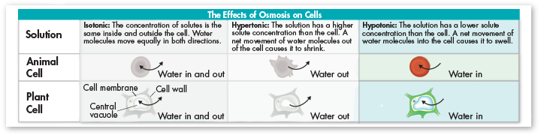

QUESTION ANSWER IN COMPLETE SENTENCES
- Explain the function of the cell membrane.
- The cell membrane is said to be selectively permeable. What does selectively permeable mean?
- Besides controlling what goes in and out of the cell, what other two jobs does the cell membrane have?

QUESTION ANSWER IN COMPLETE SENTENCES
4) The cell membrane is made of a phospholipid bilayer. What does the phospholipid bilayer provide for the cell?
5) What are the three molecules the cell membrane is primarily made of?
6) What is the role of each molecule in the cell membrane?
Lipids –
Proteins –
Carbohydrates –
7) Define Homeostasis.
8) Explain how an owl maintains homeostasis in regards to temperature.
9) What is Passive Transport?
10) Does Passive Transport require any energy from the cell?
11) What does “moving down the concentration gradient”?
12) What are the three types of passive transport?
13) Describe the three types of passive transport.
14) What types of molecules can diffuse through the cell membrane without using a channel protein?
15) Why is it so important for your body to maintain water or sugar homeostasis?

16) Application Question (NOT in the text): Why do your finger look like prunes after swimming for a long time? Explain.

17) Application Question (NOT in the text): Why can’t Nemo live in a fish tank filled with goldfish? Explain.

18) Application Question (NOT in the text): What would happen to your cells if you tried to drink ocean water. Explain.

