Realizing Our Budding Opportunities Today

**ROBOT!**

Team 698

Community Outreach Manual

ROBOT!

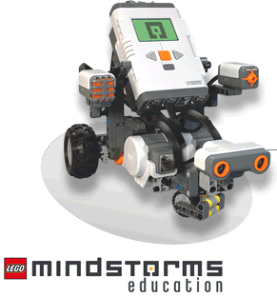

**Introduction**

Welcome to the world of robotics community outreach. Reaching out and spreading science is a key principle of FIRST, one way to do this is through events for children in the area, especially children who would most likely otherwise not be exposed to robotics. The purpose of this manual is to allow you to set up and run an easy, fun event in your area. Numerous community organizations welcome teams to come in and put on events, including the Boys and Girls Club and the Girl and Boy Scouts. Community outreach is not only good for your team members, school, and community, but it also can help in winning different outreach awards at competition. Good Luck.

**Logistics**

We might not love logistics as much as UPS does, but they are a critical part to events going smoothly. The event outlined in this manual is for kids aged 8-12 (4-6th grade). This event is also based off having access to multiple LEGO Robots, but could be adapted to just being the big robot and the design process, or only building and programming, or big robot, design process, and building, etc. This outline is intended to serve many purposes—either a guide to run a program just like the one outlined (and tested by Team 698) or a reference to take ideas from and form/expand one’s own program. Either is perfectly fine. To put on a program, even with a manual, takes time and dedication for it to go smoothly. Gathering supplies can be time consuming and training team members to lead stations and doing “dry runs” (practice events with other team members acting as kids or with younger siblings) can also eat up meetings, but when you finish and the kids are happy and have learned something, it will all be worth it. To plan an event (or two) comfortably will probably take two or three months. The first thing that needs to be done once your team decides to put an event on is contact community organizations—they are busy and so are you, so it might take some time to find a date that works for everyone. Once you have a date decided, advertise, advertise, advertise. The more you advertise, the more kids will come, and the more successful the event will be. A flyer is attached to hang up at the organization or in the community, but do not forget the importance of social media. Then spend the rest of the time preparing through gathering materials and training, this could be done through once a week meetings and still be successful. This can also be a great opportunity to get your team working together and problem solving before build season rolls around.

**Schedule of Activities**

Schedule for event starting at 1pm:

12:30- Begin setting up

1:00- Event Begins

1:00- Group introduction

1:15- Group Design Process

1:52- Rotate

1:56- First Station

2:33- Rotate

2:37- Second Station

3:14- Rotate

3:18- Third Station

3:55- Group Closing

4:00- Event Ends

4:00- Start cleaning up

4:30- End of Clean up

Stations are 37 minutes long with a four-minute transfer period between stations to allow for far apart stations, bathroom breaks, etc. 2-3 people working a station, with 10-12 kids in each rotating group. If you cannot see the next station from the station you are at, send a responsible person to escort them.

**Group Introduction**

Once all, or most, of the students are present, start with the introduction power point. Following are the slides for the power point. A copy of the power point can be gained by e-mailing [team698@gmail.com](mailto:team698@gmail.com) . If you do not have access to power point at the locale you are doing an event, the group introduction can be done just by explaining the key points of the slides orally.

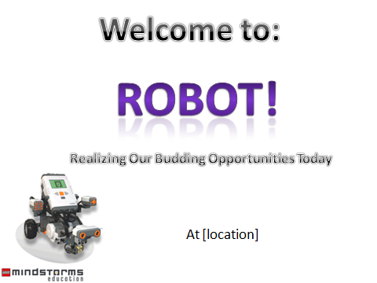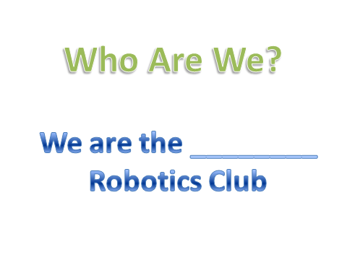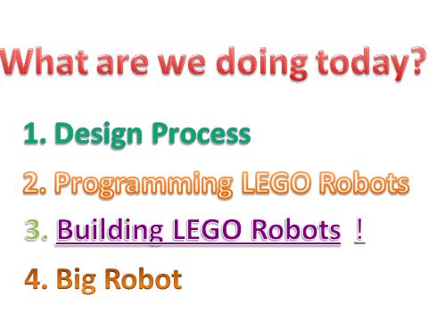

The hyper links for the Building LEGO Robots and the ! are: <http://www.youtube.com/watch?v=XG3XutQ9Lqw> (a robot made out of Mindstorms riding on a segway made out of Mindstorms) and <http://www.youtube.com/watch?v=fa7IAvvYPOs&feature=fvwp&NR=1> (a spider made out of Mindstorms)

**Group Design Process**

This follows directly after the introduction and the PowerPoint slides are as follows and are on the slide show with the introduction slides if you e-mail [team698@gmail.com](mailto:team698@gmail.com). The purpose of this is to introduce the kids to the design process without making them too bored by having already been to the interesting stations. Using the slides, walk them through the process from the definition of the process to having them draw a final robot to then share with their tablemates. Try to get them to think about what they think the design process is and then what is happening and what would work best. Depending on time or team preference, the challenge could be changed or another one added.

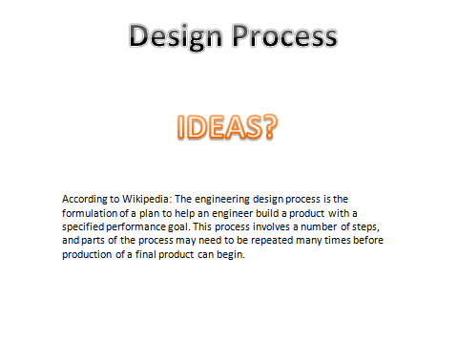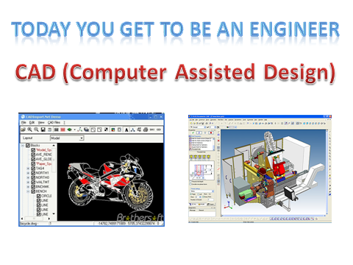

Today you get to be an engineer slide: Talk about how they get to be the engineer and design something, but they are designing it by hand and while some engineers still do some parts by hand, much more is done with CAD.

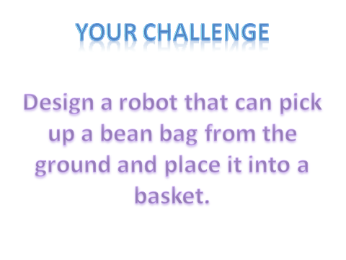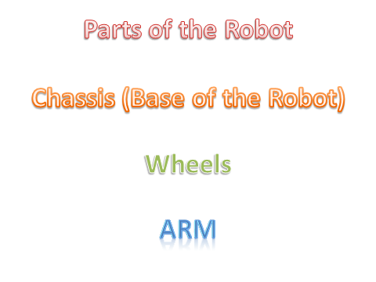

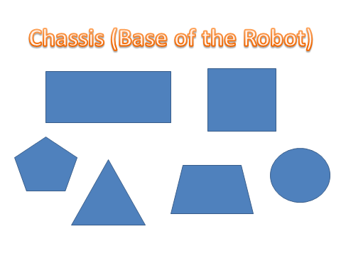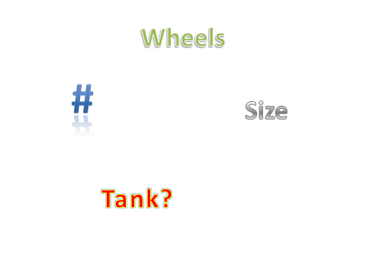

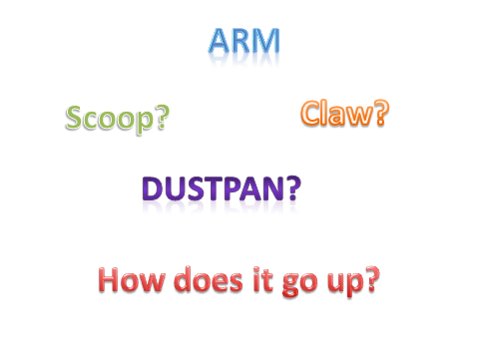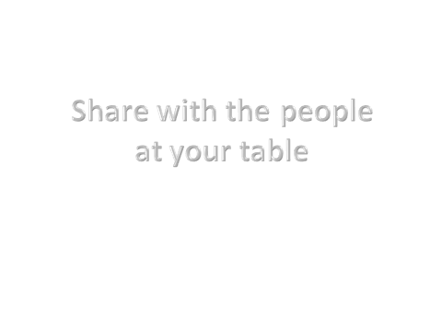

Note: All of these slides have animations to bring the words in at different times.

Need: Paper and Pencils for all the kids

After this, break the kids up into three different groups all with a “group leader” (job of group leader and what to do at each station below) and send them to the different stations following the schedule (or slightly longer or shorter time at the stations depending on how long the design process takes.)

**Stations**

Building LEGO Robots

At this station, students are given the opportunity to build with LEGO Robots. When students first arrive, ask general questions such as: who has played with LEGOs before? Who likes following directions to build something and who likes just using your imagination? Using the responses to these questions, divide the group into 2 or 3 smaller groups (depending on number of robots available and number of students in a group). Dividing into groups based on skill level helps to make sure all the kids have a chance to work with the LEGOs— i.e. so that one kid who knows a lot is not dominating everything. The groups will all be building the “five minute bot,” but it is not to be referred to as the five minute bot because it will probably take them longer than five minutes to build it. Before you give the kids the instructions briefly explain that they are going to build the robot via the instructions provided and then they can test it using programs labeled with what the program does (ex. “straight,” “backwards”) on the NXT (writing these programs is part of the gathering of supplies, so they are ready to go the day of). Once they do all of this, if time remains they may add more to their robot. Give them the instructions and let them play. Walk around and check on the different groups—splitting up from the other team member you are working with—to talk with the kids, answer questions, keep them on track, help them, etc.

Need: 3-4 robots and materials with basic program preloaded, extra batteries or charging stations, instructions for building 5-minute bot

The instructions for the five-minute bot are as follows and can be found at <http://www.nxtprograms.com/five_minute_bot/steps.html>, these instructions have the pictures so when they are printed the sizes are accurate.

Please note that neither I nor my team created this program, please respect all copyrights.

### http://www.nxtprograms.com/five_minute_bot/DCP_8917.JPGBuilding Instructions

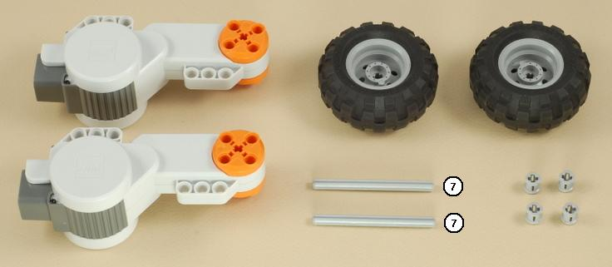**1**

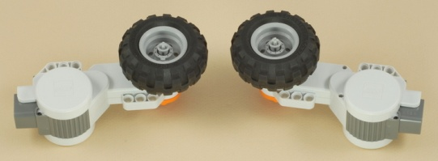

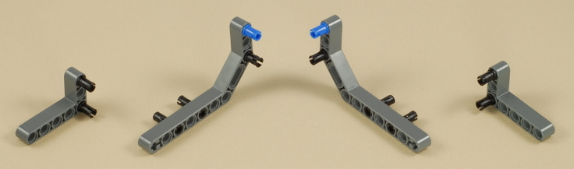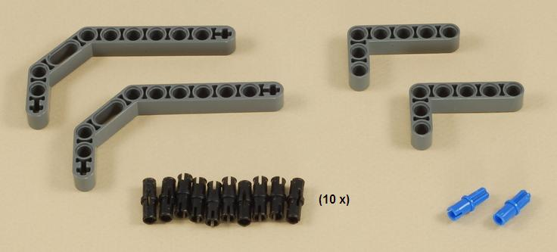**2**

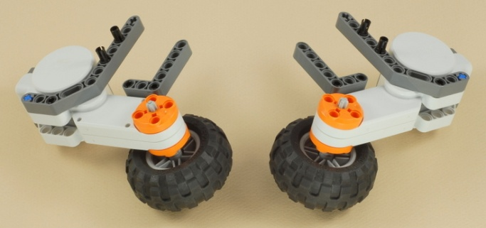

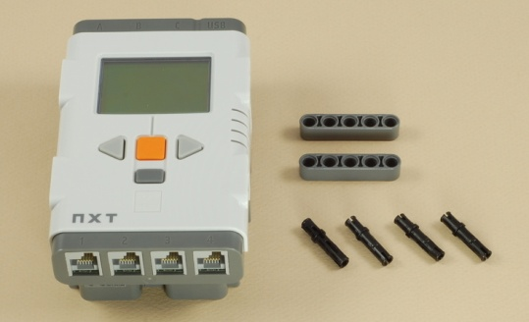**3**

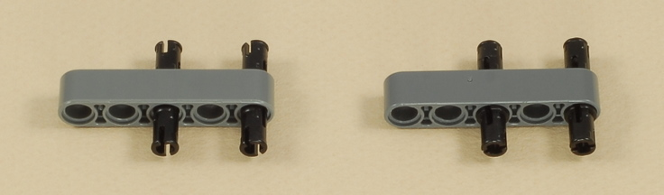

|  |
| --- |
| **Note:**You can use the NXT with either AA batteries  http://www.nxtprograms.com/five_minute_bot/DCP_8907.JPGor the NXT Rechargeable Battery Pack. |

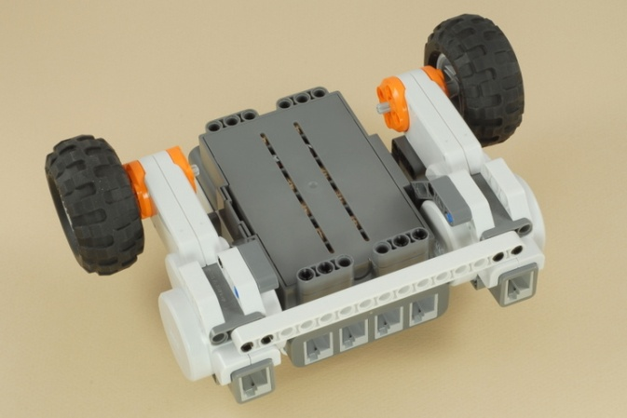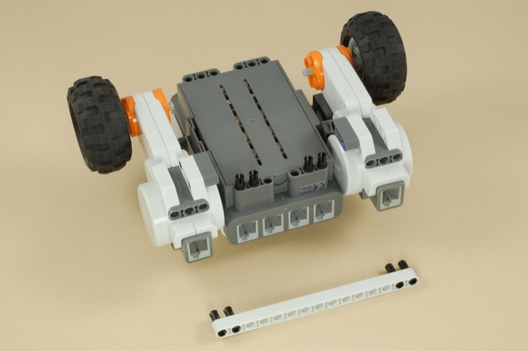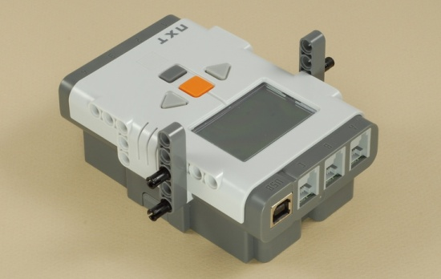**4**

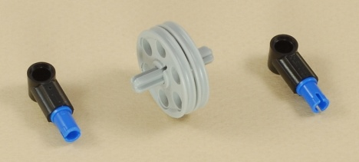

**5**

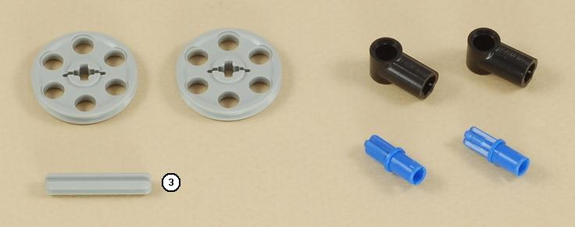

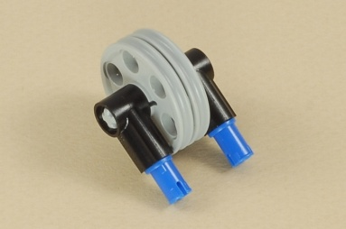

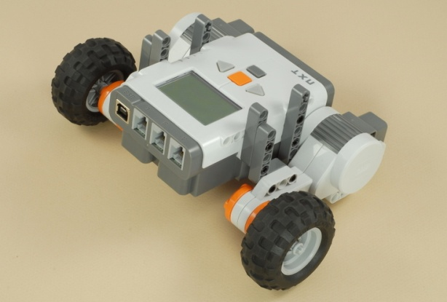

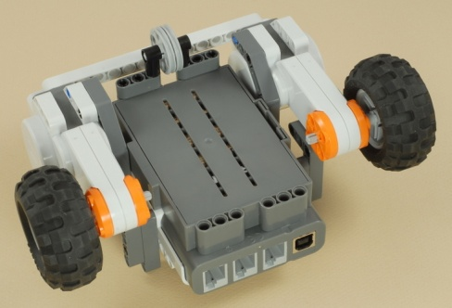

**6**

|  |
| --- |
| http://www.nxtprograms.com/five_minute_bot/DCP_8899.JPGUse two medium length (35 cm) wires to connect the motors to ports B and C on the NXT.  Make sure that the motor on each side is connected to the port on that side. |

|  |
| --- |
| Challenges   * Try writing your own programs for the Five Minute Bot to make it drive where you want.  There are even more ways to turn with the Move block or the Motor blocks (e.g. a gradual turn using the Steering slider), and there are several other settings to experiment with (power level, Brake vs. Coast, etc). * There are several places on the Five Minute Bot where additional beams can be attached to add on to the robot.  Try adding sensors, a motorized arm, or whatever you can think of. |

Programming LEGO Robots

At this station, the students are split into groups; the number depends on how many laptops/computers are available with the programming software on it. Start with talking to the kids about what the programming does (it runs the motors and other sensors, but in this case it is just going to run the motors). Have the kids all stand up and pretend that they are a robot. Start with them running towards a wall, ask what they did to accomplish the movement: answer: start moving both legs (wheels/motors) and then stop when they get close to the wall (brake). Explain or show the kids how to program a forward sequence with either a braking at the end first, but point out how to change it to coasting. Have one kid from each group program this first command—either coast or stop. Have one of the other kids program the robot to go backwards and stop. Tell them they will have a chance to load it on to the robot later after they add more commands. Have the kids stand up again and tell them to turn in a circle: ask them how they do that—turning one foot and keeping the other stable. Have a different kid program it turning in a circle. They now know the basics on how to program, so bring out the white boards with tape on them and challenge them to drive the robot up and stop at the first line. They can do this through by having a program already on the robot set to run 5 rotations and then stop and having them measure how far it goes in five rotations and dividing by 5 to figure out how far it goes in one rotation. If time remains, challenge them to park between the next set of lines or drive to the wall and stop or drive towards the wall and turn so the side of the robot is as close to the wall as possible.

Need: 3-4 Laptops with Mindstorms programming on it, 3-4 robots, tape, loading wires, rulers, calculator (4-funtion), white boards with tape on them

Large Robot Fun/Snack

This station is to show the kids that there are opportunities out there for them if they liked the LEGO Robots to expand their knowledge and skills or to inspire them if they found the LEGO Robots childish or boring. Start this station by asking how the day has been going, what did they like or what are they looking forward to. Talk with them for a little and then drive the robot your team built last year or the year before around. Make sure not to get too close to the kids while doing this. Then hand out the snack to the kids. If there is enough supervision and not too many kids, you may allow the kids to drive the robot for a little bit (limit to about a minute or less per kid). After or instead, turn the Robot off and allow the kids to look at it and ask any questions that they might have.

Need: Large Robot, Snack, props for large robot, extra battery, charger, tools to fix the easily/often broke pieces.

Group Leader

Your job is to be the leader. To establish a semi-permanent figure in your small groups of kids, to make the station leaders jobs easier. It is also to show the kids (some who might think all engineers are nerds) what the students who like math and science are really like. When we first break up into groups introduce yourself (I go to _______ High School, I am a Senior/Junior/Sophomore/Freshman, I really enjoy science/math/history and my favorite color is _____, etc.). Then have them introduce themselves (name, maybe grade or school and favorite color) you do not have to remember all of their names, but at least pay attention to their introductions. You want to be fun and outgoing with the kids to keep them engaged, but do not allow them to be rude or get too far off topic (we all go on tangents, but far tangents are a no go). The kids this should be easy, but start to pay attention to those who seem prone to getting off topic.

**Group Closing**

Gather everyone back up for an overall ending. Tell them you hope they had fun and to never give up on their dreams.

**Overall List of Materials Needed**

3-4 robots and materials with basic program preloaded

Extra batteries or charging stations for NXTs

Instructions for building 5-minute bot

3-4 Laptops with Mindstorms programming on it

3-4 robots

Tape

Loading wires

Rulers

Calculator (four function)

White Boards w/ Tape on them (programming)

Paper (enough for all kids)

Pencils (enough for all kids)

Large Robot

Snack

Props for large robot

Extra battery

Charger

Tools to fix the easily/often broke pieces

**Other Information**

Before the day of the event, go and check out the space to figure out where to set everything up.

Print out a copy of the schedule and activities for all the stations and give them to the group leaders.

**Sample Flyer**

