[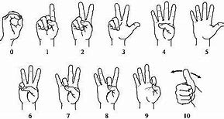](https://www.bing.com/images/search?view=detailV2&ccid=JQbpXqUi&id=75FEE1F26774299AAD5AC971C2C4FD52D462A040&thid=OIP.JQbpXqUi2-DskLyH39XkGwAAAA&mediaurl=https%3a%2f%2fmedia1.britannica.com%2feb-media%2f25%2f62625-004-FFA64B1C.gif&exph=219&expw=409&q=ASL+Signs+for+Numbers&simid=608053671699090974&selectedIndex=3)