Chapter 10

SIMPLE HARMONIC MOTION

PREVIEW

An object such as a pendulum or a mass on a spring is oscillating or vibrating if it is moving in a repeated path at regular time intervals. We call this type of motion harmonic motion. For an object to continue oscillating there must be a restoring force continually trying to restore it to its equilibrium position. For, the force exerted by an ideal spring obeys Hooke’s law. As an object in simple harmonic motion oscillates, its energy is repeatedly converted from potential energy to kinetic energy, and vice – versa.

The content contained in sections 1, 2, 3, and 4 of chapter 10 of the textbook is included on the AP Physics B exam.

QUICK REFERENCE

Important Terms

amplitude
maximum displacement from equilibrium position; the distance from the midpoint of a wave to its crest or trough.
equilibrium position
the position about which an object in harmonic motion oscillates; the center of vibration
frequency
the number of vibrations per unit of time
Hooke’s law
law that states that the restoring force applied by a spring is proportional to the displacement of the spring and opposite in direction
ideal spring
any spring that obeys Hooke’s law and does not dissipate energy within the spring.
mechanical resonance
condition in which natural oscillation frequency equals frequency of a driving force
period
the time for one complete cycle of oscillation
periodic motion
motion that repeats itself at regular intervals of time
restoring force
the force acting on an oscillating object which is proportional to the displacement and always points toward the equilibrium position.
simple harmonic motion
regular, repeated, friction-free motion in which the restoring force has the mathematical form F = - kx.

Equations and Symbols

$$\begin{aligned}F_{s}=−kx \\ {\text{PE}}_{\text{elastic}}=\frac{1}{2}{\text{kx}}^{2} \\ x=A\text{cos}ωt \\ ω=\frac{2π}{T}=2πf \\ T_{S}=2π\sqrt{\frac{m}{k}} \\ T_{P}=2π\sqrt{\frac{l}{g}} \\ T=\frac{1}{f}\end{aligned}$$

where

F_{s} = the restoring force of the spring
k = spring constant
x = displacement from equilibrium
position
PE_{elastic} = elastic (spring) potential
energy (denoted U_{s} on the AP
exam)
A = amplitude
ω = angular frequency
T = period
f = frequency
m = mass
T_{P} = period of a pendulum
T_{S} = period of a mass on a spring
g = acceleration due to gravity

Ten Homework Problems

Chapter 10 Problems 4, 6, 8, 12, 17, 27, 28, 31, 40, 41

DISCUSSION OF SELECTED SECTIONS

10.1 The Ideal Spring and Simple Harmonic Motion

An object is in harmonic motion if it follows a repeated path at regular time intervals, that is, it is oscillating. Two common examples of harmonic motion often studied in physics are a mass on a spring and a pendulum.

As a mass on a spring vibrates, it has both a period and a frequency. The period of vibration is the time it takes for one complete cycle of motion, that is the time it takes for the object to return to its original position. The frequency is the number of cycles per unit time, such as cycles per second, or hertz. The lowest point in the swing of a pendulum is called the equilibrium position, and the maximum displacement from equilibrium is called the amplitude.

Since the mass on a spring vibrates about the equilibrium position, there must be a force that is trying to restore it back toward the center of the oscillation. This force is called the restoring force, and it is greatest at the amplitude and zero as the mass passes through the equilibrium position. Newton’s second law tells us that if there is a net force, there must be an acceleration, and if the force is maximum at the amplitude, the acceleration must maximum at the amplitude as well. The velocity, however, is zero at the amplitude and maximum as it passes through the equilibrium position.

A
Equilibrium

The period and frequency of a mass vibrating on a spring depend on the stiffness in the spring. For a stiffer spring, it takes more force to stretch the spring to a particular length. The amount of force needed per unit length is called the spring constant k, measured in newtons per meter. The relationship between force, stretched length, and k for an ideal (or linear) spring is called Hooke’s law:
F_{spring} = - kx
where x is the stretched length of the spring. For an ideal spring, the stretch is proportional to the force, but in the opposite direction. If we pull with twice the force, the spring will stretch twice as far.
The graph below represents the magnitude of the force F vs stretched length x for a spring:
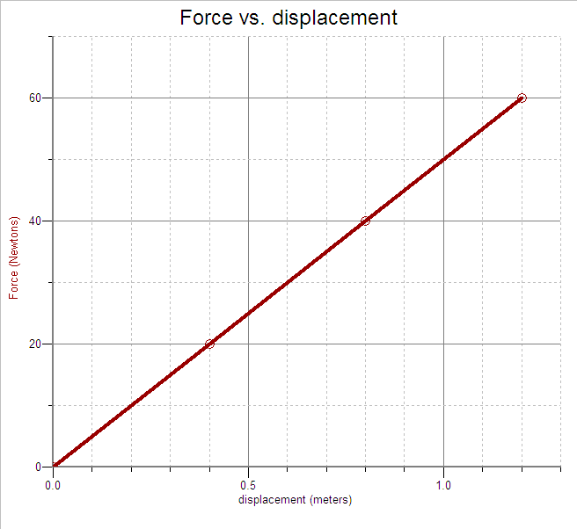
The slope of the line is the change in force (rise) divided by the change in length (run). Since this ratio is also equal to the spring constant k, the higher slope of the graph the higher the spring constant, which is an indication of the stiffness of the spring.

We can find the spring constant k for this spring by taking the ratio of the force to the stretch for a particular interval. In other words, we can find the slope of the F vs. x graph for each spring. The slope of the line and the spring constant for spring is 50 N/m.

As on any other F vs. x graph, the work done in stretching or compressing the spring to a certain displacement can be found by finding the area under the graph. The total work done in stretching this spring is
$$W=\text{Area}=\frac{1}{2}\left(\text{60} N\right)\left(1\text{.}2 m\right)=\text{36} J$$
10.2 Simple Harmonic Motion and the Reference Circle
In the equation for the spring force above, x is the displacement from equilibrium position at any time. Because of the oscillatory nature of the vibrating mass, we can express the displacement x from equilibrium position at any time t as
$x=A\text{cos}\left(ω t\right)$ or $x=A\text{sin}\left(ω t\right)$
where A is the amplitude of oscillation and ω (the lower case Greek letter omega) is called the angular frequency, and is measured in radians per second. The quantity ωt is called the phase, and is an angle in radians. The mass on the spring makes one full oscillation (2π radians) in one period T, so the angular frequency can be found by
$ω =\frac{2π}{T}=2π f$, where f is the frequency in hertz.
Another relationship between the angular frequency of a mass oscillating on a spring and the spring constant k is
$ω =\sqrt{\frac{k}{m}}$.
We see from this equation that the higher the spring constant k, the stiffer the spring, and the greater the angular frequency of oscillation. A smaller mass will also increase the angular frequency for a particular spring.
If we set the two equations above for ω equal to each other and solve for the period T of oscillation, we get
$T=2π\sqrt{\frac{m}{k}}$.
Example 1
A mass of 0.5 kg oscillates on the end of a spring on a horizontal surface with negligible friction according to the equation $x=A\text{cos}\left(ω t\right)$. The graph of F vs. x for this motion is shown below.

The last data point corresponds to the maximum displacement of the mass.
Determine the
(a) angular frequency ω of the oscillation,
(b) frequency f of oscillation,
(c) amplitude of oscillation,
(d) displacement from equilibrium position (x = 0) at a time of 2 s.

Solution:
(a) We know that the spring constant k = 50 N/m from when we looked at this graph earlier. So,
$$ω=\sqrt{\frac{k}{m}}=\sqrt{\frac{\text{50} N/m}{0\text{.}5 \text{kg}}}=\text{10} \frac{\text{rad}}{s}$$
(b) $f=\frac{ω}{2π}=\frac{\text{10} {\text{rad}}/s}{2π}=1\text{.}6 \text{Hz}$
(c) The amplitude corresponds to the last displacement on the graph, A = 1.2 m.
(d) $x=A\text{cos}\left(ωt\right)=\left(1\text{.}2 m\right)\text{cos}\left[\left(\text{10} {\text{rad}}/s\right)\left(2 s\right)\right]=0\text{.}5 m$

10.3 Energy and Simple Harmonic Motion

As an object vibrates in harmonic motion, energy is transferred between potential energy and kinetic energy. Consider a mass sitting on a surface of negligible friction and attached to a linear spring. If we stretch a spring from its equilibrium (unstretched) position to a certain displacement, we do work on the mass against the spring force. By the work-energy theorem, the work done is equal to the stored potential energy in the spring. If we release the mass and allow it to begin moving back toward the equilibrium position, the potential energy begins changing into kinetic energy. As the mass passes through the equilibrium position, all of the potential energy has been converted into
kinetic energy, and the speed of the mass is maximum. The kinetic energy in turn begins changing into potential energy, until all of the kinetic energy is converted into potential energy at maximum compression.

The compressed spring then accelerates the mass back through the equilibrium to the original starting position, and the entire process repeats itself. If we neglect friction on the surface and in the spring, the total energy of the system remains constant, that is,

Total Energy = Potential Energy + Kinetic Energy = a constant

Thus, whatever potential energy is lost must be gained by kinetic energy, and vice-versa. As long as no energy is lost to the surroundings, the mass on the spring continues to oscillate in mechanical resonance. As the spring oscillates, we can calculate the total mechanical energy at any time:
$$\begin{aligned}E_{\text{total}}=K+U \\ \text{where }K=\frac{1}{2}{\text{mv}}^{2} \text{and }U=\frac{1}{2}{\text{kx}}^{2}\end{aligned}$$
Example 2
A spring of constant k = 100 N/m hangs at its natural length from a fixed stand. A mass of 3 kg is hung on the end of the spring, and slowly let down until the spring and mass hang at their new equilibrium position.

x

(a) Find the value of the quantity x in the figure above.
The spring is now pulled down an additional distance x and released from rest.

(b) What is the potential energy in the spring at this distance?
(c) What is the speed of the mass as it passes the equilibrium position?
(d) How high above the point of release will the mass rise?
(e) What is the period of oscillation for the mass?

Solution:
(a) As it hangs in equilibrium, the upward spring force must be equal and opposite to the downward weight of the block.
mg
F_{s}

$$\begin{aligned}F_{s}=\text{mg} \\ \text{kx}=\text{mg} \\ x=\frac{\text{mg}}{k}=\frac{\left(3 \text{kg}\right)\left(\text{10} m/{s^{2}}\right)}{\text{100} N/m}=0\text{.}3 m\end{aligned}$$

(b) The potential energy in the spring is related to the displacement from equilibrium position by the equation
$$U=\frac{1}{2}{\text{kx}}^{2}=\frac{1}{2}\left(\text{100} N/m\right){\left(0\text{.}3m\right)}^{2}=4\text{.}5 J$$
(c) Since energy is conserved during the oscillation of the mass, the kinetic energy of the mass as it passes through the equilibrium position is equal to the potential energy at the amplitude. Thus,

$$\begin{aligned}K=U=\frac{1}{2}{\text{mv}}^{2} \\ v=\sqrt{\frac{2U}{m}}=\sqrt{\frac{2\left(4\text{.}5 J\right)}{3 \text{kg}}}=1\text{.}7 m/s\end{aligned}$$
(d) Since the amplitude of the oscillation is 0.3 m, it will rise to 0.3 m above the equilibrium position.
(e) $T=2π\sqrt{\frac{m}{k}}=2π\sqrt{\frac{3 \text{kg}}{\text{100} N/m}}=1\text{.}1 s$

10.4 The Pendulum

A pendulum is a mass on the end of a string which oscillates in harmonic motion. All of the concepts for the period, frequency, amplitude, and energy for a pendulum are the same as for the mass on a spring. The equation for the period of a pendulum is
$$T=2π\sqrt{\frac{L}{g}}$$
where L is the length of the pendulum, and g is the acceleration due to gravity at the location of the pendulum. A longer length will have a longer period, while a stronger gravitational field will shorten the period of a pendulum.

Example 3
A pendulum of mass 0.4 kg and length 0.6 m is pulled back and released from and angle of 10˚ to the vertical.

(a) What is the potential energy of the mass at the instant it is released. Choose potential energy to be zero at the bottom of the swing.
(b) What is the speed of the mass as it passes its lowest point?

This same pendulum is taken to another planet where its period is 1.0 second.
(c) What is the acceleration due to gravity on this planet?

Solution
(a) First we must find the height above the lowest point in the swing at the instant the pendulum is released.
h
10˚
L
L
Recall from chapter 1 of this study guide
that $h=L−L\text{cos}θ$.
Then
$$\begin{aligned}U=\text{mg}\left(L−L\text{cos}θ\right) \\ U=\left(0\text{.}4 \text{kg}\right)\left(\text{10} m/{s^{2}}\right)\left(0\text{.}6 m−0\text{.}6 m\text{cos}\text{10}°\right)=0\text{.}4 J\end{aligned}$$

(b) Conservation of energy:
$$\begin{aligned}U_{\text{max}}=K_{\text{max}}=\frac{1}{2}{\text{mv}}^{2} \\ v=\sqrt{\frac{2U}{m}}=\sqrt{\frac{2\left(0\text{.}4 J\right)}{0\text{.}4 \text{kg}}}=1\text{.}4 m/s\end{aligned}$$
(c)
$\begin{aligned}T=2π\sqrt{\frac{L}{g}} \\ g=\frac{4π^{2}L}{T^{2}}=\frac{4π^{2}\left(0\text{.}6 m\right)}{{\left(1\text{.}0 s\right)}^{2}}=\text{23}\text{.}7 \frac{m}{s^{2}}\end{aligned}$
CHAPTER 10 REVIEW QUESTIONS
For each of the multiple choice questions below, choose the best answer.
Unless otherwise noted, use g = 10 m/s² and neglect air resistance.

1. According to Hooke’s law for an ideal spring, doubling the stretch distance will
- double the velocity of the mass.
- double the force that the spring exerts on the mass.
- quadruple the force the spring exerts on the mass.
- double the period.
- double the frequency.

Questions 2 – 3: Consider the force vs displacement graph shown for an ideal spring.

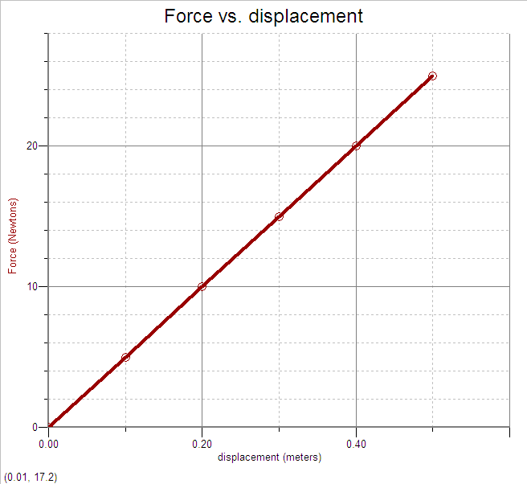

2. The work done in stretching the spring from 0.1 m to 0.5 m is
- 1 J
- 4 J
- 6 J
- 12 J
- 24 J

3. The spring constant k is equal to
(A) 5 N/m
(B) 10 N/m
(C) 20 N/m
(D) 25 N/m
(E) 50 N/m

θ
L

Questions 4 – 6:
A pendulum of length L swings with an amplitude θ and a frequency f  as shown above.

4. If the amplitude is increased and the pendulum is released from a greater angle,
- the period will decrease.
- the period will increase.
- the period will not change.
- the frequency will increase.
- the frequency will decrease.

5. If the mass and the length of the pendulum are both doubled, the frequency of vibration will be
(A) f
(B) 2f
(C) 4f
(D) ½ f
(E) ¼ f
6. Which of the following statements is true about the swinging pendulum?

I. The greatest restoring force and the
greatest velocity occur at the same
point.
II. The greatest restoring force and the
greatest acceleration occur at the same
point.
III. The greatest acceleration and the
greatest velocity occur at the same
point.

(A) I only
(B) I and II only
(C) II only
(D) I and III only
P
Equilibrium
(E) I, II, and III

Questions 7 – 9:
The equation which describes the motion of a mass oscillating on an ideal spring is
x = 6 cos 3t
where x is in centimeters and t is in seconds.

7. The amplitude of the harmonic motion is
(A) 3 cm
(B) 6 cm
(C) 9 cm
(D) 18 cm
(E) 30 cm

8. The period of vibration for this mass on a spring is most nearly
(A) 1 s
(B) 2 s
(C) 3 s
(D) 6 s
(E) 9 s

9. The total distance traveled by the mass during one full oscillation is
(A) 3 cm
(B) 6 cm
(C) 12 cm
(D) 18 cm
(E) 24 cm

10. A mass vibrates on an ideal spring as shown above. The total energy of the spring is 100 J. What is the kinetic energy of the mass at point P, halfway between the equilibrium point and the amplitude?
- 25 J
- 50 J
- 75 J
- 100 J
- 200 J

Free Response Question

Directions: Show all work in working the following question. The question is worth 15 points, and the suggested time for answering the question is about 15 minutes. The parts within a question may not have equal weight.

1. (15 points)
ℓ
A
B
h
C
x
D

A small 0.10 kg block starts from rest at point A, which is at a height of 1.0 m. The surface between points A and B and between points C and D is frictionless, but is rough between points B and C, having a coefficient of friction of 0.10. After traveling the distance ℓ = 1.0 m, the small block strikes a larger block of mass 0.30 kg, and sticks to it, compressing the spring to a maximum distance x = 0.50 m. Determine

(a) the speed of the 0.10 kg block at point B.
(b) the acceleration of the 0.10 kg block between points B and C.
(c) the speed of the block at point C.
(d) the speed of the combined small and large block immediately after they collide.
(e) the spring constant of the spring.
ANSWERS AND EXPLANATIONS TO CHAPTER 10 REVIEW QUESTIONS

Multiple Choice

1. B
Since the force is proportional to the stretch distance, the force would double if the stretch distance doubled.

2. C
The work done by the spring from 0.1 m to 0.5 m is equal to the area under the graph between those two points.
$$A=\frac{1}{2}\left(\text{20} N\right)\left(0\text{.}4 m\right)+\left(5 N\right)\left(0\text{.}4 m\right)=6 J$$
3. E
k = slope = $\frac{\text{25} N}{0\text{.}5 m}=\text{50}\frac{N}{m}$
4. C
The period of a pendulum does not depend on the amplitude of swing for small swings.

5. D
$f=\frac{1}{2π}\sqrt{\frac{g}{L}}$. Thus , $f∝\sqrt{\frac{1}{L}}$, and $\frac{1}{2}f∝\sqrt{\frac{1}{4L}}$

6. C
Newton’s second law states that the acceleration is proportional to the force. The restoring force and the acceleration are the greatest at the amplitude of swing.

7. B
The amplitude is the the constant which appears in front of the cosine of the angle.

8. B
$$T=\frac{2π}{ω}≈\frac{2\left(3\right)}{3}=2 s$$

9. E
The total distance moved during one full oscillation would be four times the amplitude of the motion: 4(6 cm) = 24 cm.

10. B
At point B, the mass is halfway between the equilibrium position, where the kinetic energy is 100 J, and the amplitude, where the kinetic energy is zero. Thus, the kinetic energy at point B is 50 J.
Free Response Question Solution

(a) 3 points
$$\begin{aligned}U_{A}=K_{B} \\ \text{mgh}=\frac{1}{2}{\text{mv}}_{B^{2}} \\ v_{B}=\sqrt{2\text{gh}}=\sqrt{2\left(\text{10} m/{s^{2}}\right)\left(1\text{.}0 m\right)}=4\text{.}5 m/s\end{aligned}$$

(b) 3 points
The frictional force and acceleration between points B and C is
$$\begin{aligned}f=μN=μ\text{mg}=\text{ma} \\ a=\frac{f}{m}=−\frac{μ\text{mg}}{m}=−μg=−\left(0\text{.}\text{10}\right)\left(\text{10} m/{s^{2}}\right)=−1\text{.}0 m/{s^{2}}\end{aligned}$$

(c) 2 points
$$\begin{aligned}v_{C^{2}}=v_{B^{2}}+2aℓ \\ v_{C}=\sqrt{v_{B^{2}}+2aℓ}=\sqrt{{\left(4\text{.}5 m/s\right)}^{2}+2\left(−1\text{.}0 m/{s^{2}}\right)\left(1\text{.}0 m\right)}=4\text{.}3 m/s\end{aligned}$$

(d) 3 points
Conservation of momentum:
$$\begin{aligned}{\text{mv}}_{C}=\left(m+M\right)v_{C^{′}} \\ v_{C^{′}}=\frac{{\text{mv}}_{C}}{\left(m+M\right)}=\frac{\left(0\text{.}\text{10} \text{kg}\right)\left(4\text{.}3 m/s\right)}{\left(0\text{.}\text{40} \text{kg}\right)}=1\text{.}1 m/s\end{aligned}$$

(e) 4 points
The kinetic energy of the two blocks just after the collision is equal to the potential energy in the spring.
$$\begin{aligned}K_{C^{′}}=U_{D} \\ \frac{1}{2}\left(m+M\right)v_{C^{}}=\frac{1}{2}{\text{kx}}^{2} \\ k=\frac{\left(m+M\right)v_{C^{}}}{x^{2}}=\frac{\left(0\text{.}\text{40} \text{kg}\right){\left(1\text{.}1 m/s\right)}^{2}}{{\left(0\text{.}5 m\right)}^{2}}=1\text{.}9 N/m\end{aligned}$$

