Chapter 6

WORK AND ENERGY

PREVIEW

Work is the scalar product of the force acting on an object and the displacement through which it acts. When work is done on or by a system, the energy of that system is always changed. If work is done slowly, we say that the power level is low. If work is done quickly, the power level is high. Kinetic energy is the energy an object has because of its motion, and potential energy is the energy an object has because of its location or configuration. If the energy of a system remains constant throughout a process, we say that energy is conserved.

The content contained in all sections of chapter 6 of the textbook is included on the AP Physics B exam.

QUICK REFERENCE

Important Terms

conservative force
a force which does work on an object which is independent of the path taken by the object between its starting point and its ending point
conserved properties
any properties which remain constant during a process
energy
the non-material quantity which is the ability to do work on a system
joule
the unit for energy equal to one Newton-meter
kinetic energy
the energy a mass has by virtue of its motion
law of conservation of energy
the total energy of a system remains constant during a process
mechanical energy
the sum of the potential and kinetic energies in a system
potential energy
the energy an object has because of its position
power
the rate at which work is done or energy is dissipated
watt
the SI unit for power equal to one joule of energy per second
work
the scalar product of force and displacement
Equations and Symbols

$$\begin{aligned}W=F⋅s=\left(F\text{cos}θ\right)s \\ \text{KE}=\frac{1}{2}{\text{mv}}^{2} \\ W={\text{KE}}_{f}−{\text{KE}}_{0}=\frac{1}{2}{\text{mv}}_{f^{2}}−\frac{1}{2}{\text{mv}}_{0^{2}} \\ \text{PE}=\text{mgh} \\ W_{g}=Δ{\text{PE}}_{g}=\text{mg}\left(h_{0}−h_{f}\right) \\ {\text{PE}}_{0}+{\text{KE}}_{0}={\text{PE}}_{f}+{\text{KE}}_{f} \\ P=\frac{W}{t} \\ P=F⋅v=\left(F\text{cos}θ\right)v\end{aligned}$$

where
W = work
F = force
s = displacement
F • s = scalar product of force and
displacement
KE = kinetic energy
v = velocity or speed
m = mass
PE = potential energy (denoted as U on
the AP Physics exam)
g = acceleration due to gravity
h = height above some reference point
P = power
t = time

Ten Homework Problems

Chapter 6 Problems 8, 10, 16, 20, 61, 64, 67, 73, 77, 78

DISCUSSION OF SELECTED SECTIONS

6.1 Work Done by a Constant Force

As you know by now, there are many words in physics that have meanings which are well-defined but not necessarily used in the way they are normally used outside of the context of a physics course, and work is certainly one of these words. In physics, work is defined as the scalar product of force and displacement, that is,
W = F·s = Fscosθ
θ
Fcosθ
Fsinθ
F
s

where θ is the angle between the applied force and the displacement. Here, the force and displacement vectors are multiplied together in such a way that the product yields a scalar. Thus, work is not a vector, and has no direction associated with it. Since work is the product of force and displacement, it has units of newton-meters, or joules (J). A joule is the work done by applying a force of one newton through a displacement of one meter. One joule is about the amount of work you do in lifting your calculator to a height of one
meter. For work to be done on an object, the force must have a component in the same direction as the displacement.
6.2 The Work – Energy Theorem and Kinetic Energy
Energy is the ability to do work, and when work is done, there is always a transfer of energy. Energy can take on many forms, such as potential energy, kinetic energy, and heat energy. The unit for energy is the same as the unit for work, the joule. This is because the amount of work done on a system is exactly equal to the change in energy of the system. This is called the work-energy theorem.

Kinetic energy is the energy an object has because it is moving. In order for a mass to gain kinetic energy, work must be done on the mass to push it up to a certain speed, or to slow it down. The work-energy theorem states that the change in kinetic energy of an object is exactly equal to the work done on it, assuming there is no change in the object’s potential energy.

$$W=Δ\text{KE}=\frac{1}{2}{\text{mv}}_{f^{2}}−\frac{1}{2}{\text{mv}}_{o^{2}}$$

The work done on a system can also be converted into heat energy, and usually some of the work is.
6.3 Gravitational Potential Energy
Potential energy is the energy a system has because of its position or configuration. When you stretch a rubber band, you store energy in the rubber band as elastic potential energy. When you lift a mass upward against gravity, you do work on the mass and therefore change its energy. The work you do on the mass gives it potential energy relative to the ground. To lift it, you must apply a force equal to the weight mg of the mass through a displacement height h, and thus the work done in lifting the mass is

W = Fs = (mg)h

which must also equal its potential energy

PE = mgh

6.4 Conservative Forces versus Nonconservative Forces, and the Work – Energy Theorem
A force is said to be conservative if the work done by the force does not depend on the path taken between any two points. The gravitational force and the spring force are two examples of conservative forces. These two forces conserve energy during a round trip. A force is said to be nonconservative if the work done by the force depends on the path taken. Friction is the most common example of a nonconservative force on the AP Physics B exam, since a taking longer path will dissipate more heat energy. Work done by a nonconservative force generally cannot be recovered as usable energy.
6.5 The Conservation of Mechanical Energy
When work is done on a system, the energy of that system changes from one form to another, but the total amount of energy remains the same. We say that total energy is conserved, that is, remains constant during any process. This is also called the law of conservation of energy.

We can use the fact that the sum of the potential and kinetic energies remains constant during free fall to solve for quantities such as speed or initial height.

U_{top} + K_{top} = U_{bottom} + K_{bottom}
mgh_{top} + ½ mv_{top}² = mgh_{bottom} + ½ mv_{bottom}²

The sum of the kinetic and potential energies of a system is called the total mechanical energy of the system. These same principles can be applied to a block sliding down a frictionless ramp, a pendulum swinging from a height, and many other situations. We could use Newton’s laws and kinematics to solve these types of problems, but usually conservation of energy is easier to apply.

B
C
A
2R
D
E
h
x
Example 1
A small block of mass m begins from rest at the top of a curved track at a height h and travels around a circular loop of radius R. There is negligible friction between the block and the track between points A and D, but the coefficient of kinetic friction on the horizontal surface between points D and E is μ. The distance between points D and E is x.
Answer all of the following questions in terms of the given quantities and fundamental constants.

(a) Determine the speed of the block at point B, at the bottom of the loop.
(b) Determine the kinetic energy of the block at point C, at the top of the loop.

After the block slides down the loop from point C to point D, it enters the rough portion of the track. The speed of the block at point E is half the speed of the block at point D.

(c) Determine the speed of the block at point D, just before it enters the rough portion of
the track.
(d) Determine the amount of work done by friction between points D and E.
(e) Find an expression for the coefficient of kinetic friction μ.

Solution
Since there is no friction on the track between points A and B, there is no loss of energy. Thus,

$$\begin{aligned}U_{A}=K_{B} \\ \text{mgh}=\frac{1}{2}{\text{mv}}_{B^{2}}\end{aligned}$$
Solving for v_{B} ,

$$v_{B}=\sqrt{2\text{gh}}$$

(b) Conservation of energy:

$$\begin{aligned}U_{A}=U_{C}+K_{C} \\ \text{mgh}=\text{mg}\left(2R\right)+K_{C} \\ K_{C}=\text{mgh}−2\text{mgR}\end{aligned}$$

(c) There is no energy lost on the track between points A and D, so the speed of the block at point D is the same as the speed at point B:
$v_{D}=\sqrt{2\text{gh}}$

(d) The work done by friction is the product of the frictional force and the displacement through which it acts.
$$W_{f}=\text{fx}={μF}_{N}x=μ\text{mgx}$$

(e) The frictional force causes the block to have a negative acceleration according to Newton’s second law:
$$a=\frac{f}{m}=\frac{−μ\text{mg}}{m}=−μg$$
Using a kinematic equation,

$$\begin{aligned}v_{E^{2}}=v_{D^{2}}+2\text{ax} \\ 0={\left(\sqrt{2\text{gh}}\right)}^{2}+2\left(−μg\right)x \\ μ=\frac{2\text{gh}}{2\text{gx}}=\frac{h}{x}\end{aligned}$$

6.7 Power
Work can be done slowly or quickly, but the time taken to perform the work doesn’t affect the amount of work which is done, since there is no element of time in the definition for work. However, if you do the work quickly, you are operating at a higher power level than if you do the work slowly. Power is defined as the rate at which work is done. Oftentimes we think of electricity when we think of power, but it can be applied to mechanical work and energy as easily as it is applied to electrical energy. The equation for power is

$$P=\frac{\text{Work}}{\text{time}}$$

and has units of joules/second or watts (W). A machine is producing one watt of power if it is doing one joule of work every second. A 75-watt light bulb uses 75 joules of energy each second.
Example 2
Motor
h
v
m
A motor raises a mass of 3 kg to a height h at a constant speed of 0.05 m/s. The battery (not shown) which provides energy to the motor originally stores 4 J of energy, all of which can be used to lift the mass.

(a) What is the power developed in the motor?
(b) To what maximum height can the motor lift the mass using its stored energy?

Solution
(a) $P=\frac{W}{t}=\frac{\text{Fh}}{t}=\frac{\left(\text{mg}\right)h}{t}=\left(\text{mg}\right)v=\left(3\text{kg}\right)\left(\text{10} m/{s^{2}}\right)\left(0\text{.}\text{05} m/s\right)=1\text{.}5 \text{Watts}$
(b)
$$\begin{aligned}W=\text{mgh} \\ h=\frac{W}{\text{mg}}=\frac{4 J}{\left(3\text{kg}\right)\left(\text{10} m/{s^{2}}\right)}=0\text{.}\text{13} m\end{aligned}$$
6.9 Work Done by a Variable Force
Graphically, the work done on an object or system is equal to the area under a Force vs. displacement graph:

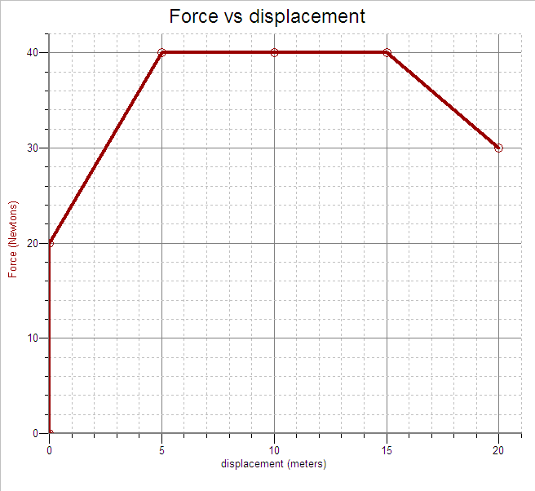

The area under the graph from zero to 20 meters is 1450 N m. Thus, the force represented by the graph does 1450 J of work. This work is also a measure of the energy which was transferred while the force was being applied.

Supplemental Section: Potential Energy vs. Displacement Graphs

Since work done by a force is equal to the product of the force and the displacement through which it acts, the area under a force versus displacement graph is equal to the work done. Doing work on a system changes the energy of that system. Consider the potential energy versus displacement graph below:

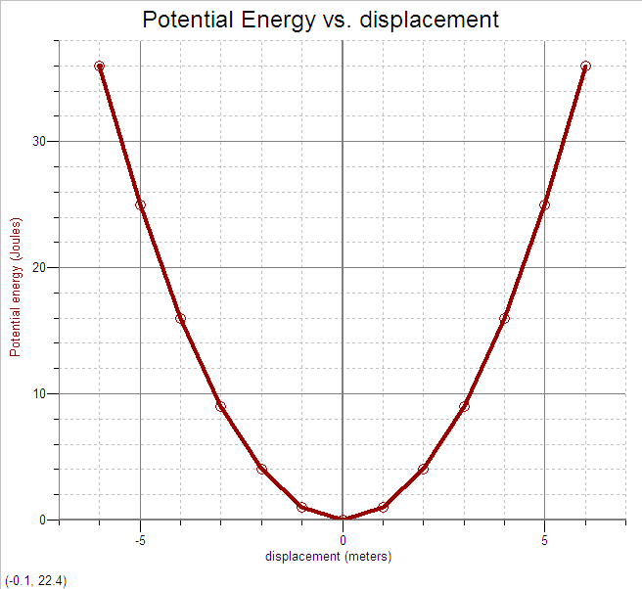

This graph could represent the potential energy of a mass oscillating on a spring, as the work done on the spring is equal to the potential energy at any point on the graph. That potential energy in turn is converted into kinetic energy as the mass is accelerated by the spring. The total energy of the system remains constant.

Example 3 Let’s say the total energy of the object represented by the U vs. x graph above is 20 J. This means that the sum of the potential and kinetic energy of the object at any displacement is 20 J, even though the potential energy on the graph goes higher than 20 J.

(a) What is the relationship between the potential energy and the displacement of this object?
(b) What is the potential energy of the object when it is at a displacement of – 2 m?
(c) What is the maximum displacement of the object?
(d) What is the kinetic energy of the object when it is at a displacement of 3 m?
(e) What is the speed of the object when it is at a displacement of 3 m?

Solution
(a) Since the U vs. x graph is a parabola, the potential energy must be directly proportional to the square of the displacement, that is, $U∝x^{2}$.
(b) If we go over to x = - 2, and go up to meet the graph, the potential energy is 4 J.
(c) The maximum displacement of the object corresponds to the maximum potential energy, which is 20 J. If we look up 20 J on the graph, we find that the corresponding displacement is approximately ± 4.4 m.
(d) The potential energy that corresponds to x = 3 m is 9 J. Since the total energy is 20 J, the kinetic energy at this displacement must be 20 J – 9 J = 11 J.

(e)
$$\begin{aligned}K=\frac{1}{2}{\text{mv}}^{2} \\ v=\sqrt{\frac{2K}{m}}=\sqrt{\frac{2\left(\text{11} J\right)}{3 \text{kg}}}=2\text{.}7 m/s\end{aligned}$$

CHAPTER 6 REVIEW QUESTIONS
For each of the multiple choice questions below, choose the best answer.
Unless otherwise noted, use g = 10 m/s² and neglect air resistance.

1. Which of the following is NOT true of work?
- It is the scalar product of force and displacement.
- It is measured in joules.
- It has the same units as energy.
- It is a vector which is always in the same direction as the displacement.
- It takes energy to perform work

2. A 4-kg box is pushed across a level floor with a force of 60 N for a displacement of 20 m, then lifted to a height of 2 m. What is the total work done on the box?
- 200 J
- 400 J
- 1120 J
- 1200 J
- 1280 J

3. A 20-kg cart is pushed up the inclined plane shown by a force F to a height of
3 m. What is the potential energy of the cart when it reaches the top of the inclined plane?
3m
F
- 1500 J
- 630 J
- 600 J
- 300 J
- 150 J

4. A ball falls from a height h from a tower. Which of the following statements is true?
- The potential energy of the ball is conserved as it falls.
- The kinetic energy of the ball is conserved as it falls.
- The difference between the potential energy and kinetic energy is a constant as the ball falls.
- The sum of the kinetic and potential energies of the ball is a constant.
- The velocity of the ball is constant as the ball falls.

5. A 0.5-kg ball is dropped from a third story window which is 20 m above the sidewalk. What is the speed of the ball just before it strikes the sidewalk?
- 5 m/s
- 10 m/s
- 14 m/s
- 20 m/s
- 200 m/s

6. Drew lifts a 60-kg crate onto a truck bed 1 meter high in 3 seconds. Connor lifts sixty 1-kg boxes onto the same truck in a time of 2 minutes. Which of the following statements is true?
- Drew does more work than Connor does.
- Connor does more work than Drew does.
- They do the same amount of work, but Drew operates at a higher power level.
- They do the same amount of work, but Connor operates at a higher power level.
- Drew and Connor do the same amount of work and operate at the same power level.

7. A crane can lift a 500 kg mass to height of 30 m in 2 minutes. The power at which the crane is operating is
- 125 Watts
- 1250 Watts
- 7500 Watts
- 250 000 Watts
- 500 000 Watts

Free Response Question

Directions: Show all work in working the following question. The question is worth 15 points, and the suggested time for answering the question is about 15 minutes. The parts within a question may not have equal weight.

1. (15 points)
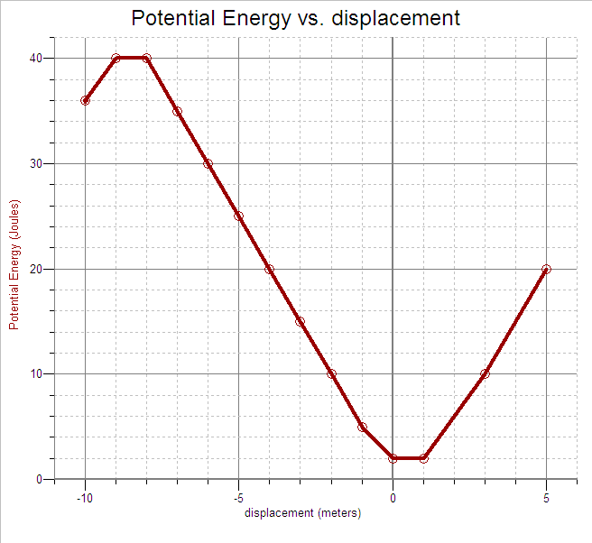
The potential energy U of 2.0 kg object as a function of distance x from its equilibrium position is shown above. The object is acted upon by a force F. This particular object has a total energy E of 30 J.
(a) What is the magnitude of the force F acting on the object between the displacements
x₁ = - 2 m and x₂ = - 6 m?
(b) What is the magnitude of the acceleration of this object between the displacements
x₁ = - 2 m and x₂ = - 6 m?
(c) Can the object reach a displacement of x = - 8 m? Explain.
(d) The object first reaches its maximum kinetic energy at which displacement?
(e) Determine the change in the speed of the object between x = 3 m and x = 5 m.
ANSWERS AND EXPLANATIONS TO CHAPTER 6 REVIEW QUESTIONS

Multiple Choice

1. D
Work is not a vector quantity.

2. E
$$W_{\text{total}}=\text{Fs}+\text{mgh}=\left(\text{60} N\right)\left(\text{20} m\right)+\left(4 \text{kg}\right)\left(\text{10} m/{s^{2}}\right)\left(2 m\right)=\text{1280} J$$

3. C
The potential energy is equal to the work done against gravity:
$$W=\text{mgh}=\left(\text{20} \text{kg}\right)\left(\text{10} m/{s^{2}}\right)\left(3 m\right)=\text{600} J$$

4. D
As the ball falls, the potential energy decreases and the kinetic energy increases, but the sum of the two remains constant.

5. D
Conservation of energy:
$$\begin{aligned}U_{\text{top}}=K_{\text{bottom}} \\ \text{mgh}=\frac{1}{2}{\text{mv}}^{2} \\ v=\sqrt{2\text{gh}}=\sqrt{2\left(\text{10} m/{s^{2}}\right)\left(\text{20} m\right)}=\text{20} m/s\end{aligned}$$
6. C
Both do $W=\text{mgh}=\left(\text{60} \text{kg}\right)\left(\text{10} m/{s^{2}}\right)\left(1 m\right)=\text{600} J$of work, but Drew does it in less time, and therefore operates at a higher power level.

7. B
$$P=\frac{W}{t}=\frac{\text{Fh}}{t}=\frac{\left(\text{mg}\right)h}{t}=\frac{\left(\text{500} \text{kg}\right)\left(\text{10} m/{s^{2}}\right)\left(\text{30} m\right)}{\text{120} s}=\text{1250} \text{Watts}$$

Free Response Question Solution

(a) 4 points
The magnitude (absolute value) of the force acting on the object is equal to the slope of the U vs x graph:
$$F=\frac{\text{30} J−\text{10} J}{−2 m−\left(−6 m\right)}=5 N$$

(b) 2 points
$$a=\frac{F}{m}=\frac{5 N}{2 \text{kg}}=2\text{.}5 m/{s^{2}}$$

(c) 2 points
The object cannot reach – 8m, since this displacement corresponds to a potential energy of 40 J, which is greater than the total energy of the object, 30 J.

(d) 2 points
Since the total energy is constant, the maximum kinetic energy occurs when the minimum potential energy first occurs at x = 0.

(e) 5 points
The change in speed between x = 3 m and x = 5 m can be found from the change in kinetic energy between these two points, which is equal to the change in potential energy between the same two points. At x = 3 m the kinetic energy is 28 J and at x = 5 m the kinetic energy is 10 J. Thus,

$$\begin{aligned}v_{3}=\sqrt{\frac{2K_{3}}{m}}=\sqrt{\frac{2\left(\text{28} J\right)}{2\text{kg}}}=7\text{.}5 m/s \\ v_{5}=\sqrt{\frac{2K_{5}}{m}}=\sqrt{\frac{2\left(\text{10} J\right)}{2\text{kg}}}=3\text{.}2 m/s \\ Δv=7\text{.}5 m/s−3\text{.}2 m/s=4\text{.}3 m/s\end{aligned}$$

