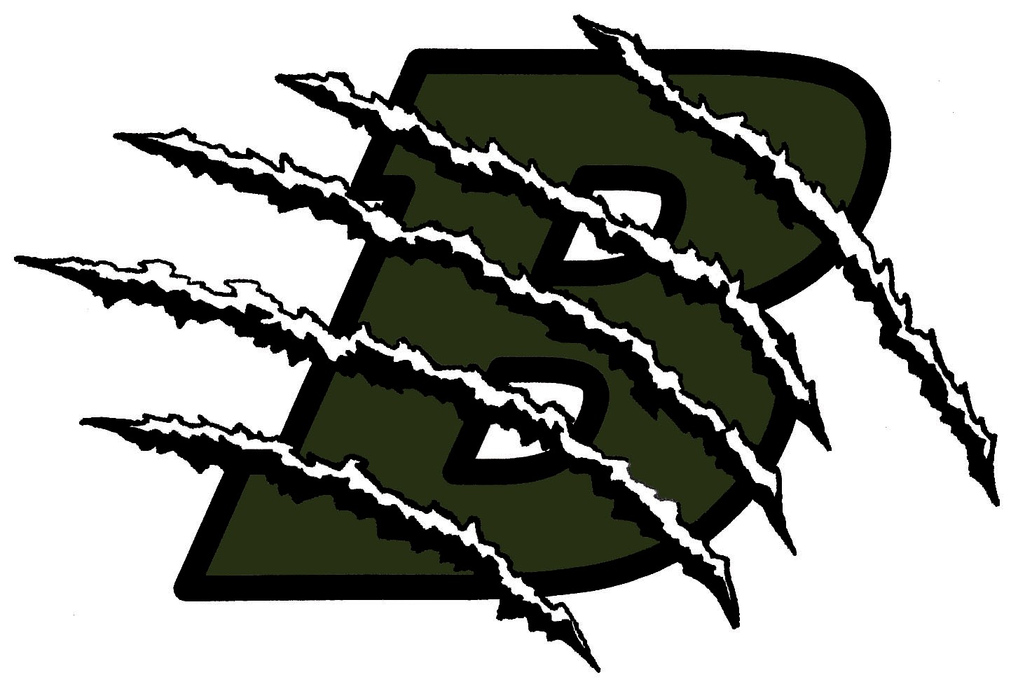
Classroom Expectations:

- Be in class on time. The tardy policy will be enforced.

- Listen, have patience, and show respect for self and others. Profanity is not allowed. Poor behavior will result in, 1. Student-Teacher conference. 2. Parent phone call/ referral.

- Clean-up. The last ten minutes of class are reserved for clean-up. During clean-up, students will return all materials to their proper place clean up your area or workstation and help out where needed. Failure to clean or follow a reasonable request will result in loss of participation points.

- Quarter Clean-up. At the end of each nine week period, all students will complete a cleaning assignment which includes but is not limited to cleaning tables, sinks, enlarger stations and lab. Failure to do so will result in loss of points. Clean-up assignments may occur more than once a quarter if needed.

- Bathroom passes are for emergencies only, abuse (using phone, wandering) will result in the bathroom privilege being revoked.

- No Food or Drinks are allowed. (An exception is made for Bottled Water)

- Do Not bring valuables to class, they will get stolen and Basha High will not be responsible.

- Put your phones away when Mr. Garcia is conducting class. Be courteous and use common sense. If you have an emergency tell Mr. Garcia.

- Do not write on your desk or any other piece of School property. Take pride in our School, don’t deface it.

- Do not sit on top of desks or counter tops.

- Please respect all class equipment, report any damages and return checked out equipment on the date specified.

- Remember: This class is a Privilege. Don’t abuse that Privilege.

- Conference period will be on Wednesday and Thursday from 9:17 - 9:45. During this time students are only allowed out of the classroom if they have a pass signed by a teacher or a club pass. The library is not available during conference. Students should use this time to study or read.

- All individuals have a right to an educational environment free from bias, prejudice and bigotry. As members of the Basha High School educational community, students are expected to refrain from participating in acts of harassment that are designed to demean another student’s race, gender, ethnicity, religious preference, disability or sexual orientation.

