Fall Semester Honors Final Review Guide 2015

Name ____________________________________________ Date _________ Period_______

Scientific Method
A scientist named Dr. Smartee, wondered why his two favorite fish, Flotsem and Jetsem were not growing at the same rate. Flotsem, a male, was growing at a faster rate than Jetsem, also a male. He bought the fish at the same time and the fish salesman assured him that they were the same age. He thought that maybe one fish was eating all the food during feeding time. The scientist decided to do an experiment. He separated the fish into two different tanks and fed them the same amount of food for two weeks, made sure they had the same amount of light, and kept the solute levels the same. After two weeks he weighed the fish and was amazed by the results. Flotsem’s weight had increased by 1 gram, and Jetsem’s weight increased by 4 grams.

- What was the independent variable in the above scenario?
  - The fish

- What was the dependent variable in the above scenario?
  - Their Weight

- What are two controlled variables that were identified in the above scenario?
  - Different tanks, same amount of food, same light, same solute levels

- What were the results of this scenario?
  - Flotsems weight went up by 1 gram, Jetsem’s weight went up by 4 grams

- Did the results support Dr. Smartee’s hypothesis?
  - Yes, he suspected that one fish was eating all of the food.

- Could Dr. Smartee conclude that Flotsem was stealing Jetsem’s food or is another explanation possible for the results?
  - It is possible, but since Jetsem gained 4 grams after being separated, it is likely that he was not getting enough food

- Graph the Result

Weight increase

Flotsem Jetsem
fish

Cells

- Label the cell: Plant, Animal, or Prokaryote.

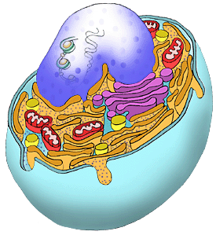

Cell type:____animal____________

Label the following organelles:

- Mitochondria
- Nucleus
- Rough ER
- Smooth ER
- Lysosomes

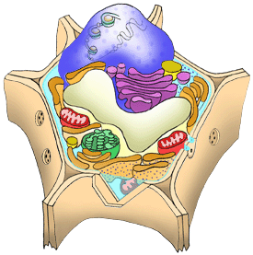
Cell type:___plant_____________

Label the following organelles:

- Chloroplast
- Central vacuole
- Cell wall

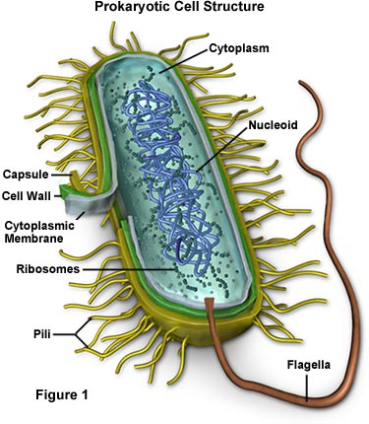
Cell type:__bacteria (prokaryote)____

C
Label the following organelles:

A - Flagella
B - Ribosomes
C- Cytoplasm
D - Cell Wall
D
E - Cell membrane
E
B

A

- What molecule in the cell contains hereditary information (instructions for growth and development)? DNA
- What is a prokaryote? Give an example.
  - Contains NO membrane bound organelles, ex. Bacteria

- What is a eukaryote? Give an example.
  - A cell that contains a nucleus and membrane bound organelles, ex. Plant or animal

- List 2 differences between prokaryotes and eukaryotes?
  - Eukaryote has a nucleus and membrane bound organelles
  - Eukaryote has double helix DNA and prokaryote has circular DNA

- What cells were most likely the first cells on Earth? (Prokaryotes or Eukaryotes?)
prokaryotes

- List three differences between plant and animal cells?
  - Plant cells have a cell wall
  - Plant cells have chloroplasts
  - Plant cells have a central vacuole

- What is an organelle? A smaller working unit within a cell

- What is a biotic factor? Give an example. – Living – tree, bird, flower, human

- What is an abiotic factor? Give an example. nOn –living – rocks, water, air

- In the table below list the function of each of the organelles.

Organelle | Function
Cell membrane | The outer boundary of the cell, semi permeable to only allow certain things in and out
Cytoplasm | Interior substance of the cell
Nucleus | Stores genetic information, Directs the activities of the cell
Nucleolus | Site where ribosomes are produced and assembled
Mitochondria | “power houses” of the cell, Produce energy (ATP) for the cell
Ribosomes | Site of protein synthesis/ involved in the production of proteins
Endoplasmic Reticulum | A system of membranous tubules and sacs, Functions as an “intercellular highway” or transport system
Golgi Apparatus | A system of membrane tubules, Modifies and packages proteins for export out of the cell
Lysosomes | Membrane sacs containing powerful enzymes, Digests worn out organelles and foreign substances that enter the cell
Cytoskeleton | Maintains the size and shape of the cell, Made up of microfilaments and microtubules, Anchors the cell’s organelles and other components of the cytoplasm
Cillia | Tiny hair-like projections on the surface of the cell that assist with movement
Cell wall | Protective outer covering of plant cells, Made mostly of cellulose, Provides support and maintains that shape of the cell, Connects the cell with adjacent cells
Vacuole | Storage organelle in plant cells, Stores water, wastes, nutrients, and enzymes, Provides plants with rigidity , Large organelle- can occupy up to 90% of a plant cell’s volume
Chloroplast | Site of photosynthesis

- What organelles are found only in plant cells?
Central vacuole, cell wall, chloroplast

Cellular Transport

- What is homeostasis? What organelle helps maintain homeostasis?
  - The ability to maintain a constant internal environment ; the cell membrane

- What will happen to a cell placed in the following environments? Draw each using X’s as solutes and an arrow representing solution movement.

Hypertonic Hypotonic Isotonic

- More X’s on the outside - more X’s on the inside equal X’s
- Water moves out - water moves in no movement

- Complete the following summary table.

Type of solution | Where is solute concentration the highest (inside cell or outside cell) | Will water move in or out of cell? | Will the cell swell, shrink, or stay the same size?
Hypertonic | Outside the cell | Water will move out of the cell | The cell will shrink
Hypotonic | Inside the cell | Water will move in the cell | The cell will swell
Isotonic | Equal inside and outside | No net movement | Stay the same size

- What are two differences between active transport and passive transport?

Active = Low → high and requires energy
Passive = High → low and does NOT require energy

- List and describe the types of passive transport.

  - Diffusion- movement of molecules from an area of high concentration to low concentration
  - Osmosis- movement of water across a semi permeable membrane from high concentration to low concentration
  - Facilitated diffusion- movement of molecules from high concentration to low concentration with the aid of carrier proteins.

- List and describe the types of active transport.

- Sodium potassium pump- Moves Na+ out of the cell and K+ inside the cell
- Exocytosis- Process where cells release substances to the outside of the cell. The substances are contained inside a vesicle that fuses with the cell membrane releasing the substance to the outside of the cell.
- Endocytosis- Process where cells ingest substances. The substances are enclosed by a portion of the cell membrane that folds into itself to form a pouch that separates from the cell membrane.

- What is the difference between osmosis and diffusion?
  - Osmosis is the movement of water, diffusion is the movement of small, non-polar particles, aside from water

- What is the difference between endocytosis and exocytosis?

Endo = entering Exo = exiting (larger quantities of molecules)
Water

Properties of Water
- Complete the chart:
- What is surface tension?
  - Brought on by hydrogen bonding, it is the strength of the surface of the water (allows it to “bend”
- What is cohesion?
  - Water is attracted to other water molecules

- What is adhesion?
  - Water is attracted to other substances

- What is capillary action?

- is adhesion in which water molecules move upward through a narrow tube, such as in a straw.

5.What is polar vs non-polar?
- have an overall charge = polar ; not having an overall charge = non-polar

- What is specific heat?
  - The amount of heat required to change 1 gram of water 1 degree Celsius.

- Water has a HIGH specific heat. Why is this property of water important to life?
  - it can absorb large amounts of heat energy before it begins to get hot. It also means that water releases heat energy slowly when situations cause it to cool. Water's high specific heat allows for the moderation of the Earth's climate and helps organisms regulate their body temperature more effectively.

- Explain hydrogen bonding.
Hydrogen of one water molecule bond with an oxygen of an adjacent water molecule

- Draw three water molecules that are bonded together. Show polarity, hydrogen bonds, and covalent bonds within your drawing.

- -
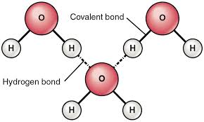

+

- Describe in words waters polarity.

Water is slightly polar due to both hydrogens being positive and the one oxygen being negative = overall charge is positive (and it is non-linear)

Mitosis/ Meiosis

- Draw the 4 stages of mitosis (label them while you’re at it… ☺).

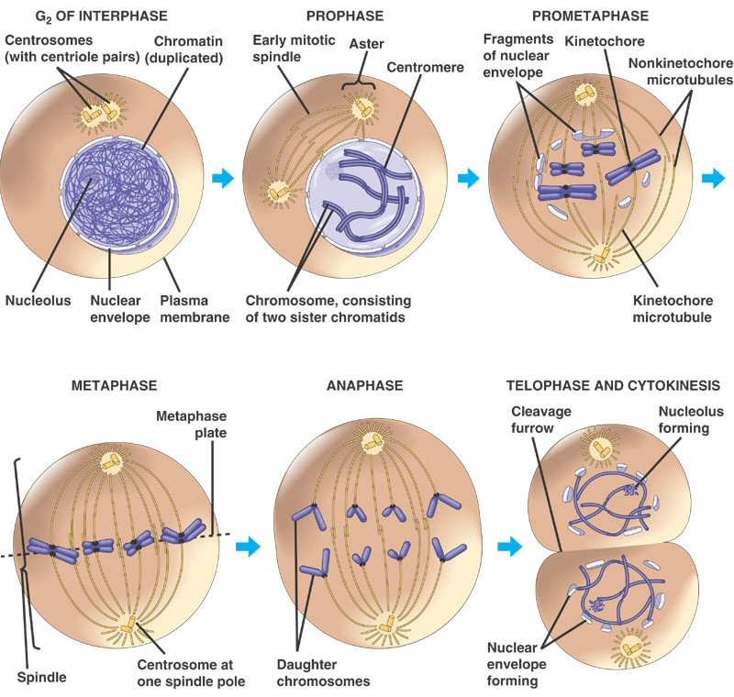

- List the phases of the cell cycle (there are 5 phases; mitosis itself is ONE of them). PIE Graph!
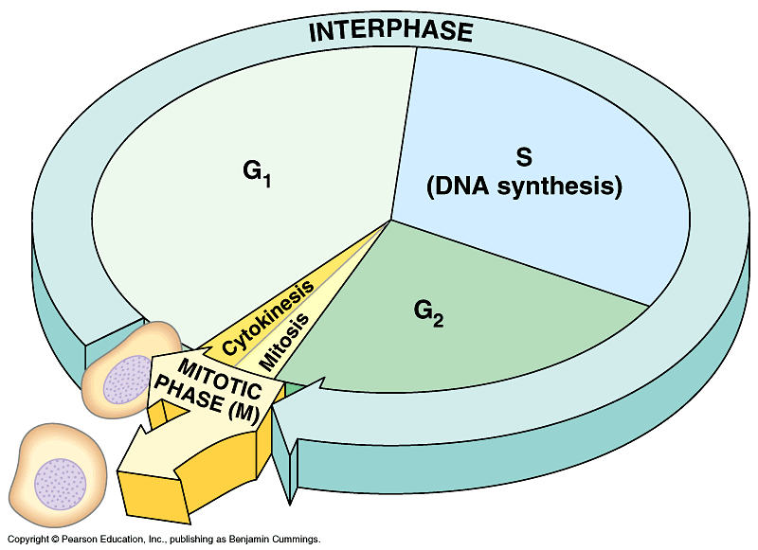

- In which phase of the cell cycle do cells spend most of their time?___Interphase______________

- What are the functions of mitosis? Growth, repair, replace

- Is interphase a stage of mitosis?___No_______ What happens during interphase?
  - Growth/
  - Protein synthesis
  - DNA replication

- How many cells are produced during mitosis?_____2__________ How many chromosomes does each contain in humans?____46___________________

- What is the function of meiosis? What are the stages of meiosis?
Make gametes and cut the genetic information in HALF

- How many times does the genetic information get split in meiosis? _twice___________

- In which phase of meiosis does crossing-over occur?__prophase__1________________

- What is crossing over and why is it important? When two homologous chromosomes exchange bits of DNA – important for genetic diversity

- How many cells are produced during meiosis? ___4_______________ How many chromosomes do they each contain?______23_____________________

- If an organism has a haploid number of 8, how many chromosomes would it have in its body (somatic) cells?______16_______________

- Explain the law of independent assortment.
Each trait has no bearing on how another trait will segregate into gametes.

Molecular Genetics (DNA, RNA, proteins)
- What does DNA stand for?___Deoxyribonucleic acid_________________
- What is a gene? A segment of DNA that codes for a trait

- What do genes code for?____trait____________
- The four nitrogen bases of DNA are (spelled out):
____adenine______, _____thymine______, ___guanine________, __cytosine__________

- _____A______pairs with_______T_____, and ______G_____ pairs with _______C______
- Compare and contrast DNA, genes, and chromosomes.
DNA is the whole meolecule, while a gene is a specific segment of that DNA. Chromosomes are the condensed for of these chunks of DNA

- What is a nucleotide? A monomer of a nucleic acid

- What are the 3 components to a nucleotide? __phosphate, sugar, base_______
- Diagram the process of DNA replication. Include the replication fork, helicase, ligase, DNA polymerase, and 3’and 5’ on both old and new strands.

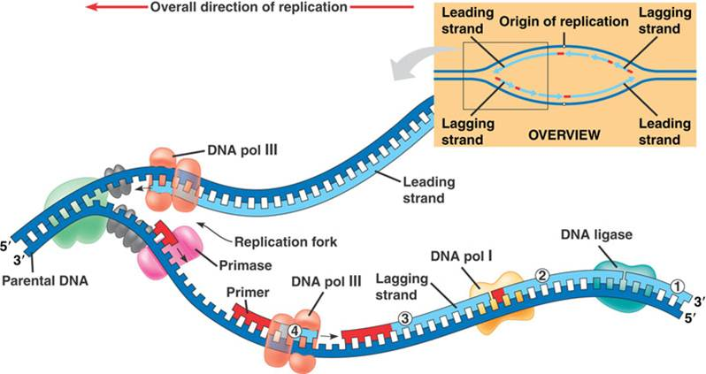

- Create the complementary DNA sequence:
5’ A-T-C-G-A-A-T-T-G-C-A-T-A-T-T-A-C 3’
3’ T A G C T T A A C G T A T A A T G 5’
- Why is DNA replication important? To make a copy to prepare for mitosis

- Why is transcription important? Why is it beneficial for the DNA? Be detailed.
Take the “code” from DNA in the form of mRNA but allow DNA to stay protected in the nuclei

- RNA uses the nitrogen base ___uracil_________ instead of _____thymine_____________.

- Create the mRNA from the following DNA:
3’ T-A-C-C-G-A-A-T-T-A-C-T-A-G-T-A-C-G 5’
5’ A U G G C U U A A U G A U C A U G C 3’

- What are the 3 types of RNA found in the cell? What are their functions?
mRNA – carry message form nucleus (DNA) to the ribosome
tRNA – transfer the amino acid to the ribosome
r RNA – (makes up the ribosome) assembles the protein

- What occurs during translation?
Decoding of the mRNA strand into an amino acid sequence
- What types of RNA are involved with translation?__All 3____________
- What types of RNA are involved with transcription?__mRNA only___ __________ _________
- What are the building blocks of protein? __amino acids________ ___________

- If an mRNA had 12 codons, how many amino acids would it code for?__4__________
- Where does transcription and translation occur in the cell? (ID both)
Transcription:___nucleus_________ Translation:____cytoplasm____ ___________
- The mRNA codon AUG codes for the amino acid __METHIONINE_____________
- The mRNA codon CCA codes for the amino acid ___Proline_____________
- Find the entire amino acid sequence for the following DNA sequence. (transcribe then translate)
3’ T-A-C-C-G-A-T-T-A-C-A-C-G-A-C-T-G-C-A-G-G 5’

You got this! ☺

- What is a mutation? What effects can mutations have?
A change in the DNA sequence
From no affect to a HUGE affect – it depends
Silent – none
Point/substitution – minimal (unless it’s a premature stop)
Insertions/deletions – can be drastic, especially at the beginning of the sequence

- . In humans, hemophilia is a sex linked trait. Females can be normal, carriers, or have the disease. Males will either have the disease or not (but they won’t ever be carriers)

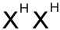 = female, normal  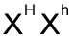= female, carrier  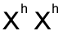 = female, hemophiliac | 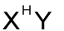= male, normal  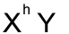= male, hemophiliac

- A. Show the cross of a man who has hemophilia with a woman who is a carrier.

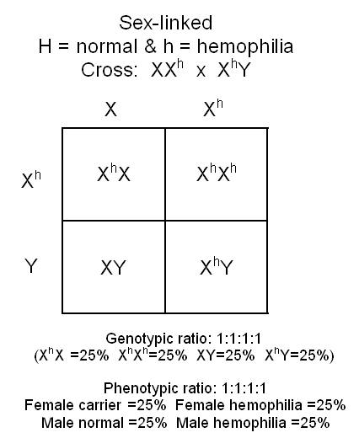

B. What is the probability that their children will have the disease? ____50%______

- A. List the possible genotypes and phenotypes of an incomplete trait, using the letter T to represent the alleles.
TT, Tt, tt

B. Complete this cross using two heterozygous parents.
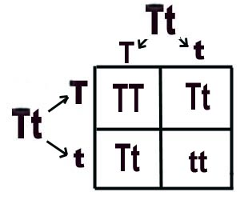

C. The probability of showing the “blended phenotype” is _50___%

D. If (T) represented black coloration, and (t) represented white coloration, what would the blended phenotype look like?
Gray

- A. List the possible genotypes and phenotypes of a co-dominant trait, using the letter R to represent the alleles.
RR, Rr, rr

B. Complete this cross using two heterozygous parents.
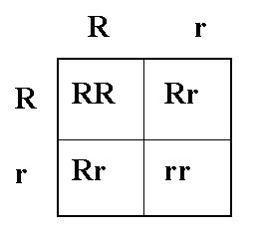

C. The probability of having the RR genotype is __25__%

D. If (R) represented red coloration, and (r) represented white coloration, what would the heterozygous genotypes display in the phenotype?
Red AND white

Macromolecules
- Know the following molecules below: their names and functions.

Nucleotide; carried genetic info simple sugar (glucose) / Carbohydrate for short term energy storage
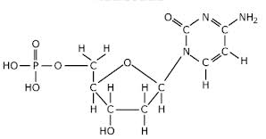
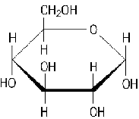
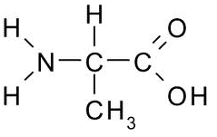
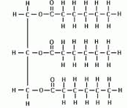

Fatty acid = LIPID amino acid = PROTEIN
Longer term energy storage structure, support, commuinication, etc.

- Overall, what is the following graph showing you?
Energy used with or without enzymes
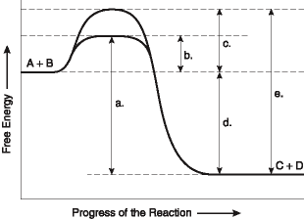

- Determine what each element of the above graph is indicating:

  - Activation energy WITH enzyme
  - Activation energy WITHOUT enzyme
  - Overall energy released from reaction (exothermic)

