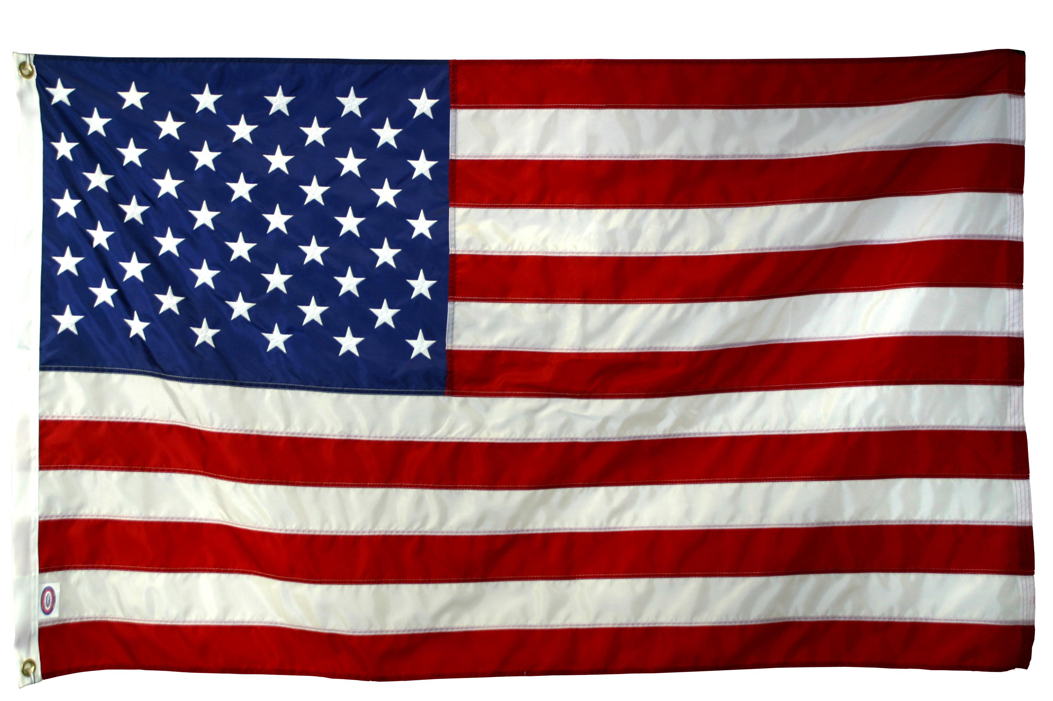
Wall of Gratitude
and Remembrance

As part of our 5th grade curriculum, and to honor the men and women who have served and continue to serve our country in the Armed Forces, each 5th grade classroom will create a Wall of Gratitude and Remembrance. This activity is quite moving and educational for the students.

Please find copies of any photos you have of individuals within your family or friends who have served, or are serving, in our country’s Armed Forces. These copies can be photocopies. Students with relatives in other states have had the pictures and information faxed, mailed, or emailed to them in years past and this has worked well. Students should conference with their teacher if they do not have a veteran family member or friend, as they will still need to complete a project about a military veteran.

Each student will need to create a small poster collage to display his/her veteran(s). The display should include photos and a short write up about each person, and should not exceed 12” x 20”.

Presentation is important. Example posters will be displayed in each class and expectations will be discussed. Students will use class time to generate interview/research questions, as well as to create the write-up draft. Final typed drafts and overall project creation will be done at home. The write up should be included on the front of each poster, as well as pasted on the back to help with presentations. Items are due Friday, November 8th.

**On Tuesday, Nov. 12th we will host a Pie Party where students will present the information learned about their honorees, with a reception to follow in the MPR. If the featured veterans are able to attend the party, please feel free to ask them to join us from 1:00 – 2:30 p.m. on November 12th . If not, we would still love you to join us to honor these heroes. ☺

Sincerely,
Ms. Brock, Mrs. Johnson, Mrs. Ryle, Ms. Sherwood, Mrs. Weber, and Mrs. Witte

