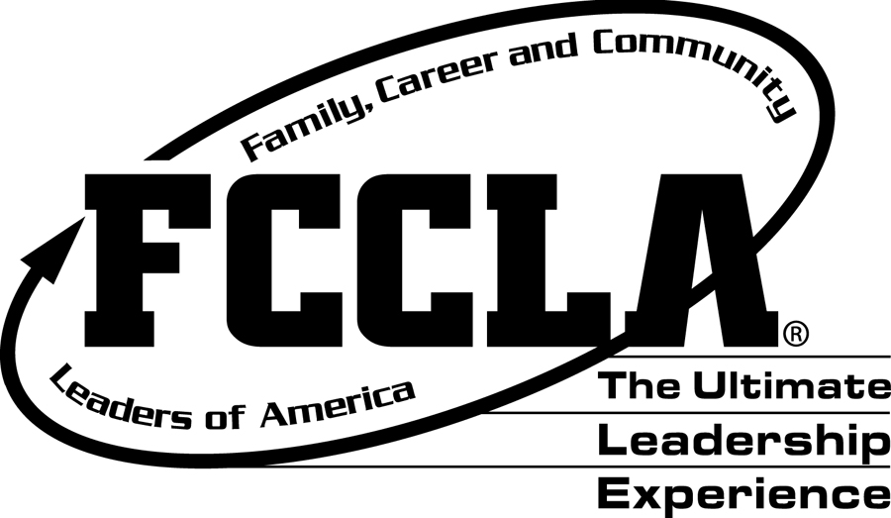
FCCLA Leadership Activities and Events
Officer Responsibilities
As an officer, you set the example for the rest of the chapter members. This is your chance to become a great leader. Becoming a chapter officer will make your time in FCCLA even more enjoyable, it will allow you to grow as a leader and will help you build relationships with many different types of people. It is a great opportunity. So don’t waste it! It is the expectation of this officer team that you give it your all. It is expected that officers are at each chapter event. Some events are mandatory (spring competition). However, we know that things happen and you are not able to come. This does NOT mean work, doctor appointments, test retakes, etc. are acceptable excuses. Please schedule these at other times. It is important that the WHOLE team is present and working together to make this year the best year yet.

Event/Activity | Date | Required or Expected or Optional
All Fundraisers | Ongoing | R
CTE Celebration (attending or volunteering) | August 13th | E
August Chapter Meeting | August 15th | R
Competition Meeting (required for new officers) | August 16th | R
August Kick-off Party | August 23rd | R
September Activity – Carnival | TBA | E
September Chapter Meeting | September 12th | R
*Fall Leadership Camp** ($135) | Sept.27th – Sept.29th | E
October Chapter Meeting | October 24th | R
October Activity | TBA | R
Fall Advisory Meeting | November 1st | O
*FCCLA Fall Leadership Conference** ($70) | November 15th | R
*FCCLA National Cluster Meeting** ($125) | November 16th–18th | O
November Chapter Meeting | November 7th | R
November Activity | TBA | R
December Chapter Meeting | December 12th | R
December Activity | TBA | R
Jr. High Tours (required for certain officer positions) | Jan. 9th - 11th | R
January Chapter Meeting | January 23rd | R
Returning Bear Night | January 16th | O
8th Grade Orientation Night | January 23rd | O
February FCCLA Week | 11th-15th | R
February Community Service | TBA | E
February Chapter Meeting | February 13th | R
February District Competition | February 19th | R
March Chapter Meeting | March 6th | R
March Advisory Board | TBA | O
*Spring Competition** ($200) | April 15th – 17th | R
April Chapter Meeting | April 24th | R
May Chapter Meeting | May 15th | R
May End of Year Banquet** (Tentative) | May 16th | R
Conference officer meetings | Weekly (Wednesdays) | R
Afterschool officer meetings (8-14-18, 9-11-18, 10-23-18, 11-5-18, 12-11-18, 1-22-19, 2-12-19, 3-5-19, 4-23-19, 5-14-19) | Monthly | R

*Please note that this is not an exhaustive list and dates are subject to change.

