Biochem Exam Review

1. List the properties of carbon that make it such a great building block of macromolecules (there are several).
2. How are hydrogen bonds created (hint: think positive and negative)
3. What are the basic chemical formulas for the following:

* Carbohydrates
* Lipids
* Nucleic acids
* Proteins

1. What type of bond connects amino acids together?
2. List the functions of lipids
3. What occurs when monomers are assembled through dehydration synthesis (Describe the process)?
4. List the functions of proteins
5. List the functions of carbohydrates
6. Define the following:

* Monosaccharide
* Polysaccharide
* Disaccharide
* Polymer
* Monomer
* Polyunsaturated lipid
* Polypeptide
* Carboxyl group
* R groups

1. Draw one water molecule and label.
2. What type of bonds stick hydrogen and oxygen together? What are the charges for hydrogen and oxygen?
3. Draw two water molecules bonded together. Be sure to label the bonds and charges.
4. Identify the following molecules:

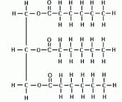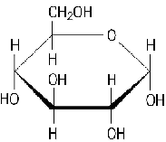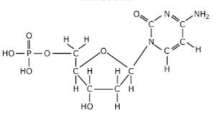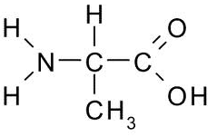

1. List the properties of water and why they are important
2. Describe capillary action, give an example.
3. What is high heat capacity?
4. What does polar mean?
5. What is an enzyme? What do enzymes do? (how to they work?)
6. What are some factors that affect enzymes?
7. Describe the lock and key model as it pertains to enzymes
8. What is a catalyst?
9. What are saturated fatty acids ( give some characteristics )? Draw one out and give an example.
10. What are unsaturated fatty acids ( give characteristics)/ Draw one out and give an example
11. How are proteins joined together and broken apart? At what bond in the protein structure does this occur? Draw out an example

Part 1: Temperature and Enzyme Activity

Use the graph below to answer questions 1-3.

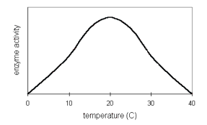

1. At what temperature does this enzyme work the fastest?

2. Why does enzyme activity increase on the left side of the graph?

3. Why does enzyme activity decrease on the right side of the graph?

4. Humans share several enzymes with thermophilic bacteria. What does the graph

below suggest about the conditions under which these thermophiles live?

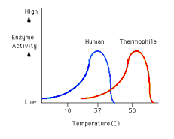

Part 2: pH and Enzyme Activity

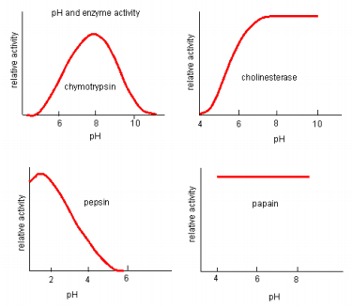

Based on the graph above:

1. Which enzyme works best in neutral conditions?
2. Which enzyme is not affected by pH?
3. Which enzyme works under alkaline conditions?
4. Which enzyme might be found in acidic gastric juices?