|  |  |  |
| --- | --- | --- |
| ***First Quarter –***  **Chemistry**: matter, atomic model, molecular motion, chemical reactions | ***Second Quarter-***  **Physics/Science Fair:** motion, velocity, acceleration,  Newton’s Thee Laws of  Motion | ***Second Quarter –***  **Physics/Science Fair**: motion, velocity, acceleration, Newton’s Three Laws of Motion |
| ***Third Quarter –***  **Genetics/Adaptations**: Mendelian Genetics, traits, cellular division, natural selection | ***Fourth Quarter –***  **Health/AZ Merit Testing**:  setting goals, emotional  health, making positive  choices |

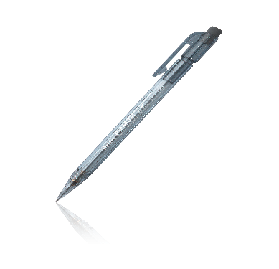

After an absence:

It is the **student’s responsibility** to collect any work after returning from an absence. Students need to ask their lab group for missing lab work and notes, as well as check the absent info folders for any missing activity sheets. Tests and quizzes will be made up before school, after school, or during lunch. **Returning students need to schedule a time for make- up assessments with Mrs. Emerich.**

**Assessments:**

Students need to be prepared for a weekly quiz EVERY Friday.

A final exam will also be given the last week of each quarter covering all material for that unit.

***Imagination is everything. It’s the preview of life’s coming attractions.***

**-Albert Einstein**

Classroom Policies –

1. Late work will receive a reduced grade.
2. Students must be in the classroom and preparing to learn when the bell rings.
3. The school-wide attendance policy will be followed.
4. No extra credit will be offered other than possibly the restroom pass.
5. No food or gum in the classroom other than bottled water.
6. Cell phones will be turned off and kept in the student’s backpack unless asked to use them for a classroom activity.

**Tutoring:**

Friday Mornings @ 8:30 in Room E37.

If choosing to break classroom rules/policies:

1. Warning
2. Parent Contact
3. Lunch Detention

* Extreme cases will result in immediate referral to the office.

**Materials to bring to class everyday:**

* Pencils
* Composition Notebook
* Highlighter
* White board markers
* Glue Stick/Tape
* Agenda

**Classroom Rules:**

1. **Respect Yourself**
2. **Respect Others**
3. **Respect Learning**

**Mrs. Emerich**

8th Grade Science - Room E37

(480) 224-2467

emerich.kristin@cusd80.com

**Welcome to Team 802**

I am excited to be your science teacher for the 2017-2018 school year and am anticipating the opportunity to guide your scientific discoveries! Please share the information below with a parent/guardian at home.

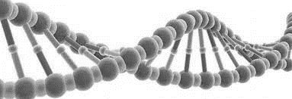

**Please sign and return the following - Science 2017-2018 Emerich**

I have read the syllabus and will follow the classroom rules and expectations. As the student it is my job to learn while I am in the classroom. I will notify my parents to any changes in the syllabus as they may occur.

Student Name (please print) _______________________________________________________

Student Signature ____________________________________ Date _____________

I have read the syllabus with my child. I am aware of the behavior expectations of my child while they are in Mrs. Emerich’s classroom.

Parent Name (please print) ________________________________________________________

Parent/Guardian Signature ______________________________Date _____________

E-mail Address ______________________________________________________________________

As a part of our curriculum your student will participate in activities/labs that may have food or chemical components. Please list any allergies that may apply.

________________________________________________________________________