**CHANDLER HIGH SCHOOL EST. 1914**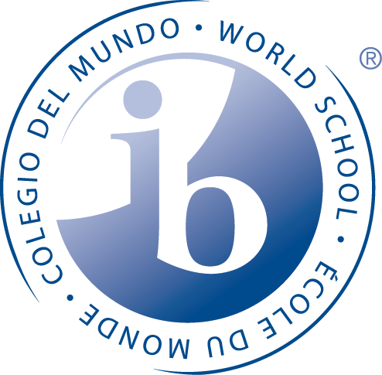

**INTERNATIONAL BACCALAUREATE WORLD SCHOOL**

***“ SCHOOL OF CHAMPIONS”***

**What is IB?**

**The International Baccalaureate Diploma Programme is an academically challenging and balanced program of education with final examinations that prepares students, aged 16 to 19, for success at the university level and life beyond.**



**What does IB look like at Chandler High School?**

* Students can be a part of the IB - Middle Years Programme (MYP) in the 9th and 10th grade. During this time they are taking Honors courses, completing community service and working on a personal project during sophomore year.
* A student does not have to be an MYP student in order to become a Diploma Candidate. However, about 70% of our Diploma Candidates have been MYP students.
* **As 11th and 12th graders, students move from ‘Honors’ courses to IB-labeled courses.**
* There is a support system of teachers, counselors, IB-MYP Coordinator, IB-DP Coordinator, IB-CP Coordinator, fellow students as mentors and parents to allow for student success in the program.
* In their junior and senior year, IB candidates complete assessments that can lead to college credit and, after successfully completing the full two-year program, the IB Career Certificate or full IB Diploma.







**Quality assurance and professional development**

Any school, or group of schools, wishing to offer one or more International Baccalaureate programmes as an IB World School must first be authorized. Chandler High School began the authorization process in 1982, graduating our first IB Diploma Candidates in 1985. The requirements are the same for all schools, and the procedure is designed to ensure that schools are well prepared to implement the programme successfully. All IB World Schools are required to participate in an ongoing process of review and development, using the same programme standards and practices.

As part of its ongoing commitment to the development of a highly skilled global learning community, the IB provides a wide range of high-quality professional development opportunities to help new, experienced and expert school leaders and educators understand, support, and successfully deliver IB programmes reflecting IB standards and practices. All IB teachers at CHS receive regular training and work in collaborative groups both at the school and with teachers from around the world.

**Why do universities value IB students?**

*IB students are prepared for academic success.*

* IB students are more likely than others to enroll in and graduate from selective higher education institutions.
* Based on their experiences, IB students possess a broader range of skills that enhance their ability to adapt and contribute to university life.
* IB students demonstrate a level of emotional and intellectual maturity for managing the demands of challenging coursework and make meaningful contributions.
* They have extensive experience doing independent research and presenting what they have learned through presentations, papers and other projects.
* They think critically and draw on diverse perspectives that reflect an international outlook.
* Participation in the IB Diploma Program shows that students have excelled in multiple and diverse academic challenges and is a strong predictor for success in university.



**CHS** *IB Diploma Graduates*

complete their degree(s) in four years or less. 

