Instructions for accessing the online textbook.

1. 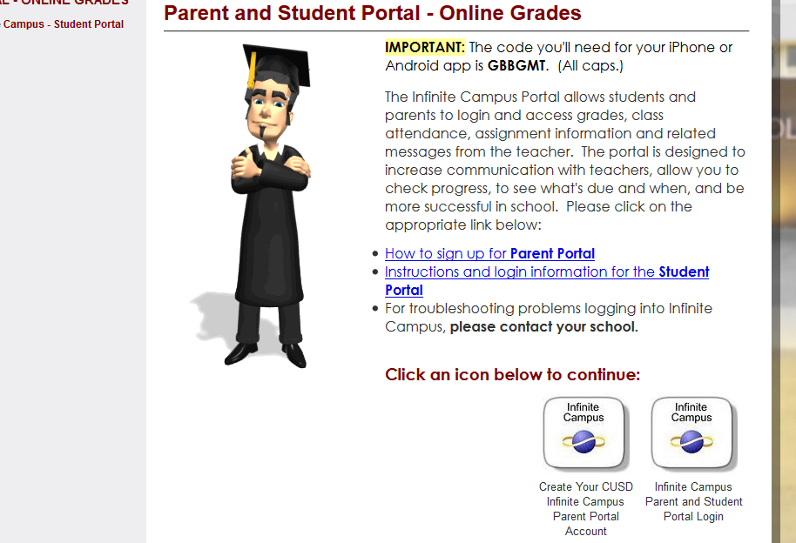Log into the student Infinite Campus. This must be done on a computer, not a cell phone. [www.cusd80.com](http://www.cusd80.com)
2. At the bottom left of the home screen, click on CUSD Student Links.

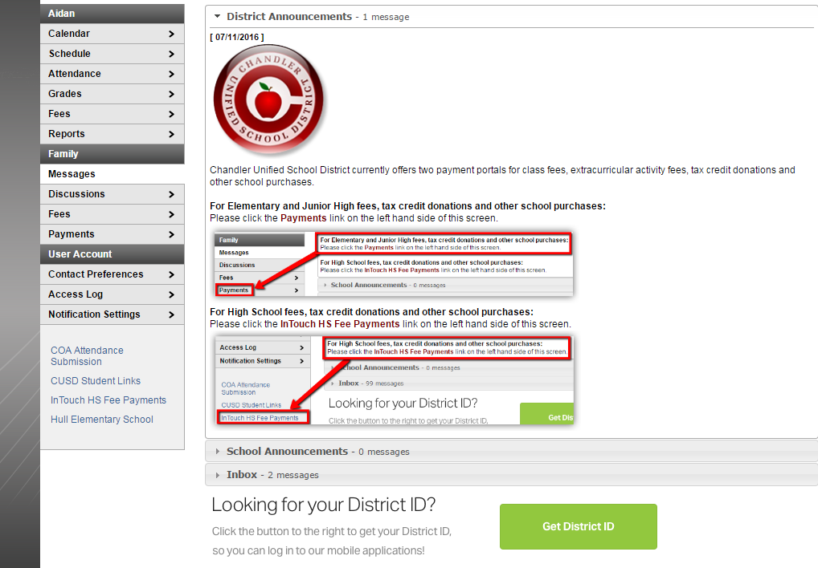

1. 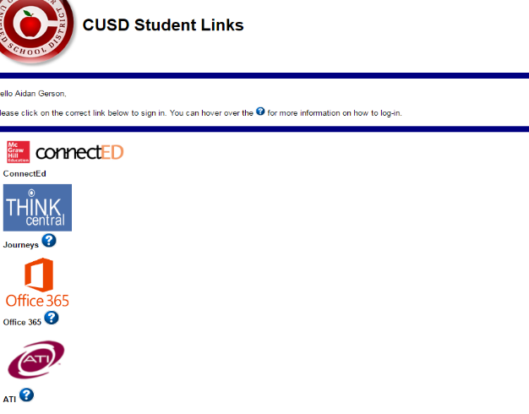Click on the ConnectED link at the top of the list.

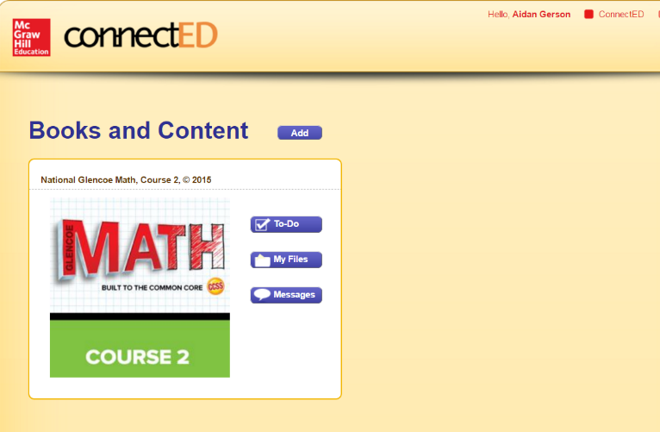

1. Click on the green Math book.
2. 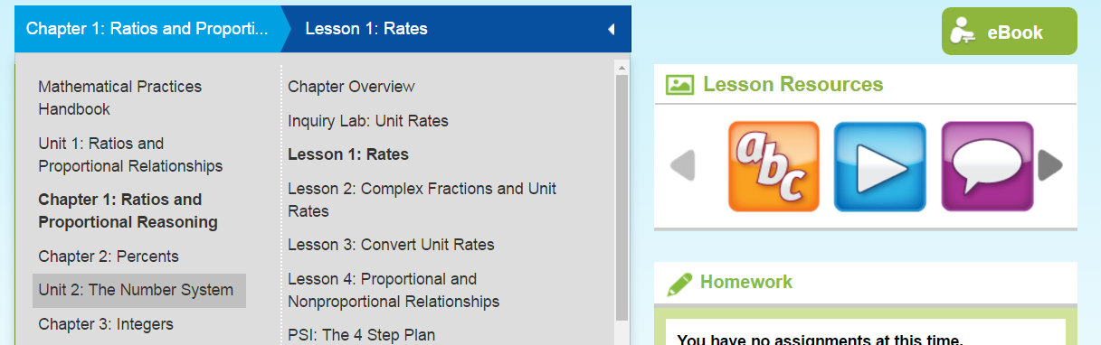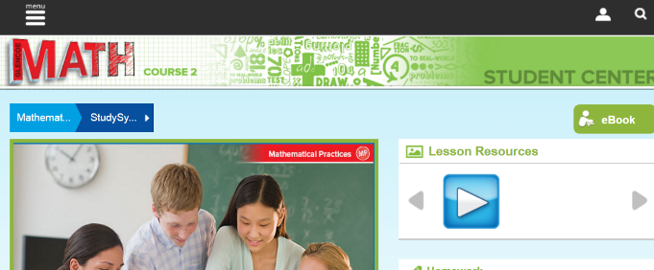Start exploring. There are lots of videos, online self-check quizzes, and the actual book is there, too. Enjoy!