**Instructions for Community Members to Make Tax Credit Donations**

*A tax credit is a dollar-for-dollar reduction in the actual tax owed. Qualifying contributions (up to $200 for individuals and up to $400 for married couples filling jointly) can be claimed on personal Arizona income taxes to reduce the amount owed or increase the refund amount.*

*These instructions are intendend for individuals that are not parents/guardians of current CUSD students. Parents/Guardians will need to make their fee payments and tax credit donations through the Infinite Campus Parent Portal.*

1. Visit <https://az-chandler-lite.intouchreceipting.com/>
2. Select the school you want to donate to from the drop-down menu.

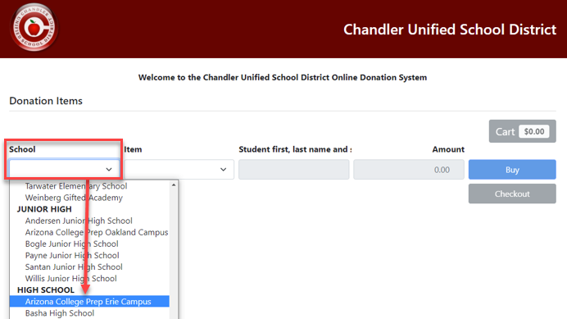

1. Select the extra-curricular program you would like to donate to from the drop-down menu.

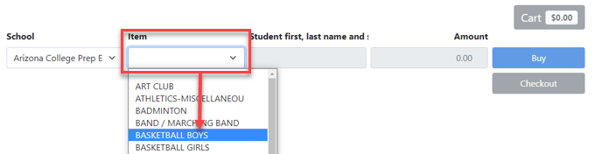

1. Next, enter the students name and student ID nubmer (if applicable).

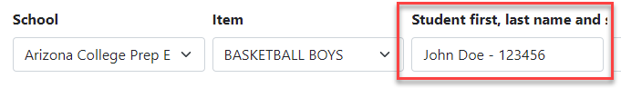

1. Enter the dollar amount of the donation and click the blue “Buy” button when complete so the item is added to your shopping cart.

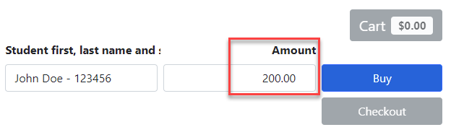

1. When you are ready to complete your payment click the green “Cart” button.

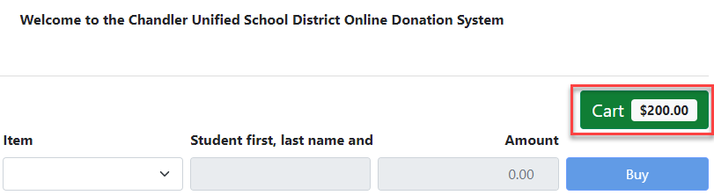

1. Review the items in your shopping cart to make sure they are correct and then click the blue “Pay” button.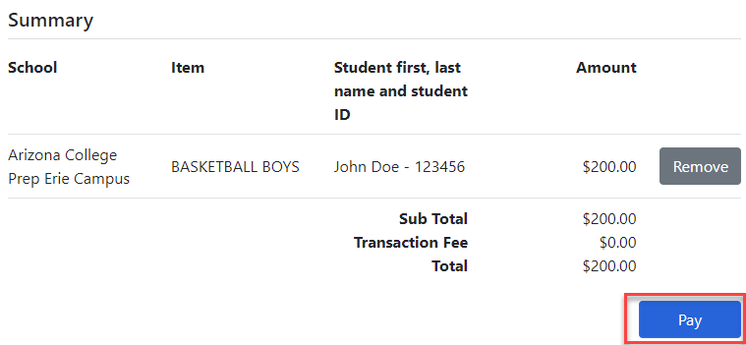
2. Enter the required fields for name, address and contact informaiton. The information you input on this screen will be used on your offical tax credit receipt. Click the “Pay” button to proceed.

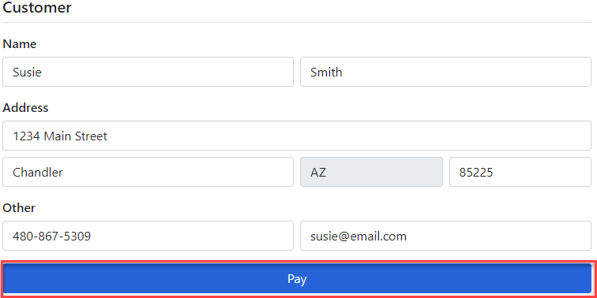

1. Next, enter the required payment informaiton and click “Pay” to complete your purchase.

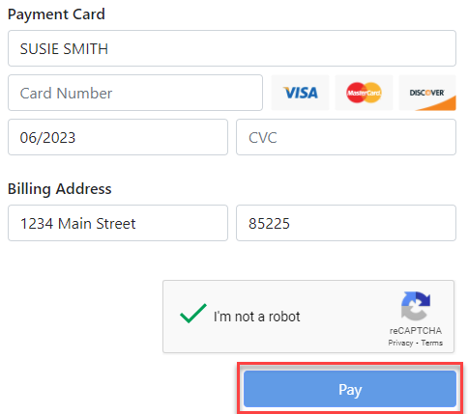

1. Your tax credit receipt will automatically generate once the payment has been made. Print or save a copy for your records.

*Please note: If you would like your tax credit donation applied directly to a student’s ECA fee please email your request with a copy of your donation receipt to Kristina Goble at* [*goble.kristina@cusd80.com*](mailto:goble.kristina@cusd80.com) *(HS sites) or Cindy Clarke at* [*clarke.cindy@cusd80.com*](mailto:clarke.cindy@cusd80.com) *(Elem & JH sites). Tax credit donations can only be applied to eligible ECA fees within the same school year.*

**Thank you for your support!**