PE Uniform Shirts

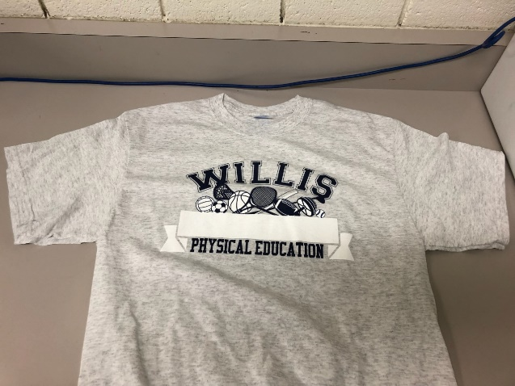

Wills P.E. students are required to “dress out” every day they have physical education. For your convenience, the P.E. department has uniform shirts. Sizes range from XS to L. Please be aware that these are adult sizes.

Uniform shirts are $10.00. **Cash only.**

If you wish to purchase a PE shirt please send payment with your student and they can purchase one during PE class.

**Students must provide their own athletic bottoms. Basketball shorts, running shorts, leggings, joggers, or sweatpants are accepted. They must be black or blue in color. **