**IB CAREER-RELATED PROGRAM**

**REFLECTIVE PROJECT GUIDE**

***Chandler High School***

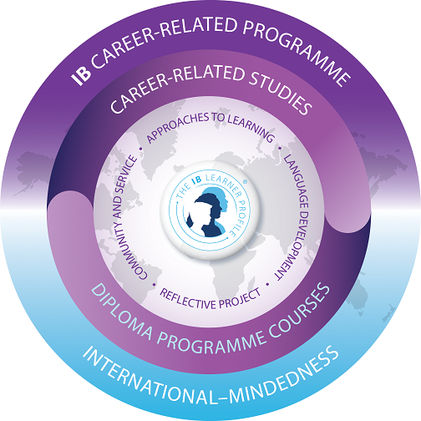

**PURPOSE**

**“**The reflective project is an in-depth body of work produced over an extended period and submitted towards the end of the IBCP. It is the product of the student’s own initiative and should reflect his or her experience of the IBCP. The reflective project is designed to draw together key elements of a student’s wider schedule of study, specifically the career-related studies, community and service and approaches to learning. It is intended to promote high-level research and writing skills, intellectual discovery and creativity.

The reflective project investigates and focuses on the ethical dimensions of an issue arising from the student’s complementary career-related studies. Students need to identify an issue of interest that they would like to explore in greater depth that arises from their career-related studies.”

(www.ibo.org/ibcc).

**TOPIC SELECTION**

Step 1: Select an issue related to your IBCP path

Step 2: Formulate a non-ethical question that simply asks you to describe what you know about the issue.

Step 3: Redraft your question so that it just asks for one solution to the problem or issue.

Step 4: Try to think of the ethical dilemma associated with the issue and open up the question so it leads to multiple answers.

Step 5: Now focus on the ethical dilemma and enlarge it so that the question now goes far beyond the limits of the original observation. Your question should have more than one right answer and require the use of argument.

* *Examine the ethical dimension associated with the issue. Consider more than one view or one side of the ethical issue.*
* *Remember, that it is the ethical dimension of the issue, and not the issue itself, which is the primary focus of the reflective project!*
* *Develop a personal and relevant evaluation of the ethical dimension of the issue*

**FORMAT** 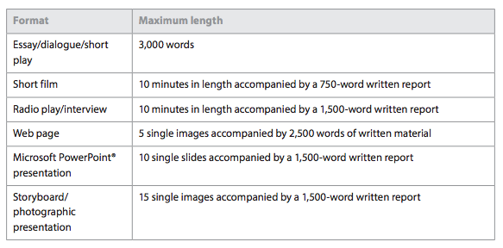

**ASSESSMENT**

Summative assessment principles are used to assess the project.

**The following are criterion for the RP.**

1. The issue in context
2. Community awareness
3. The ethical dimension of the issue
4. Cultural awareness
5. Reasoning
6. Supporting evidence
7. Student voice
8. Reflection
9. Communication
10. Presentation

**Students will be assessed on the following:**

The descriptors are a measure of performance and should not be considered as marks, although the descriptor levels are ultimately added together to obtain a total. The school should assess all reflective projects. A sample will then be selected by the IB and sent to an external moderator for confirmation of the school’s marks. The maximum score for the reflective project is 30. Any student awarded a grade of E for the reflective project will not be awarded the IBCP Certificate. Students will also receive a grade for their work and in class presentation in their ATL class.

**The IB will award a grade based on the mark.**

26–30 A

21–25 B

16–20 C

10–15 D

0–9 E

**SCOPE AND SEQUENCE**

The Reflective Project process will be directly supported by the Approaches to Learning curriculum and students will receive feedback through the ATL classroom teacher over the course of the two year program.

**Junior Year:**

January: Students Brainstorm for RP Ethical Issues

Sample Initial Plan

Topic Approval Submission and Meeting with ATL Teacher

February: Research Begins

Notes and Sources Compiled

Initial meeting with Reflective Project Mentor (CTE teacher)

March: Research Continues

Initial Research Turn in to ATL Teacher

April: Project Outline Submitted to ATL Teacher

May: Meeting with Reflective Project Mentor (CTE teacher)

Progress plan developed for the summer

**Senior Year:**

August: Self-Reflection of Process to Date

First RP Draft Completed

Feedback from ATL Teacher

September: Peer Editing of First Draft

Second RP Draft Completed

Meeting with Reflective Project Mentor (CTE teacher)

Feedback from ATL Teacher Reviewed

November: Peer Editing of Second Draft

Final RP Draft Completed

December: Final Meeting with Reflective Project Mentor

RP ATL and IB Grade Completed

RP Presentation for ATL Class

**REFLECTIVE PROJECT PROPOSAL**

Name:

IBCP Career Track:

Graduation Year:

|  |
| --- |
| **Proposed Topic:** |
|  |
| **Proposed Ethical Dilemma:** |
|  |
| **Proposed Format and Explanation:** |
|  |
| **Proposed Working Title:** |
|  |

1. Identify three questions that you have surrounding this dilemma.
2. Identify three counter arguments critics could pursue regarding this dilemma.
3. How does this dilemma relate to your career track to help deepen your experience and understanding of this field?
4. List 10 potential research sources (primary or secondary) that may be of value to this project.
5. Describe any concerns that you may have regarding the Reflective Project process.

**By signing below, I acknowledge that I understand all the requirements of the Reflective Project. I understand that the teacher will provide “limited” mentorship through this process and guidance through the Approaches to Learning course. I also understand that if the project receives an “E” grade that the IBCP Certificate will not be issued.**

**By signing below, I acknowledge that I understand all the requirements of the Reflective Project. I understand that the teacher will provide “limited” mentorship through this process and guidance through the Approaches to Learning course. I also understand that if the project receives an “E” grade that the IBCP Certificate will not be issued.**

Student Signature: ________________________________ Date:______________

Parent Signature: _________________________________ Date:______________

ATL Teacher Signature: ____________________________ Date:_____________

CTE Teacher/Mentor Signature: ____________________________ Date:___________