Cell Membrane Review

1. Identify and label the parts of the cell membrane.

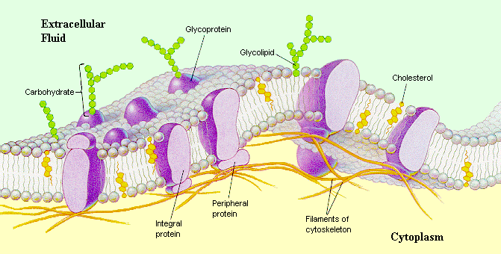

2.Define diffusion

3. Give an example of simple diffusion

4. Define Osmosis

5. Define active and passive transport and provide examples for each.

6. Explain the diagram below ( what is happening in each one?)

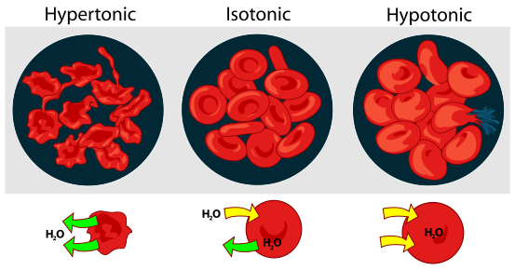

7. Describe what is going on in the diagram below.

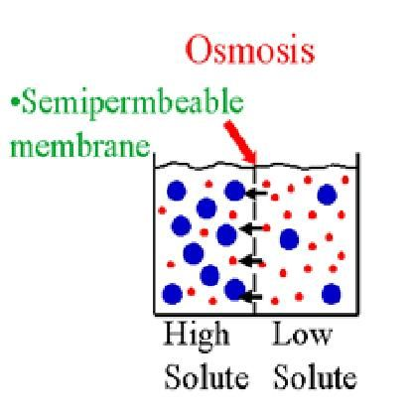

8.Define the following:

* Pinocytosis
* Phagocytosis
* Endocytosis
* Exocytosis