Proof of the period for motion for a mass on a spring



Draw a free-body diagram for the mass on a spring.

The force is always negative because when the block has positive velocity (moving to the right), the spring is expanding and bringing the mass back. When the block has negative velocity (moving to the left), the spring is compressing and pushing the block away. The force is always opposing the direction of acceleration.

Write a summation equation for the free-body diagram above:

The formula for the force on a spring is

So…

Acceleration is the time-derivative of velocity, and velocity is the time-derivative of position, which makes acceleration the second derivative of position with respect to time.

Rearranging:

Now we will create a definition:

Substituting:

This is a differential equation. We can solve this by choosing an equation for x that when you differentiate it, you get something similar back in return.

Let’s see what happens if we take consecutive derivatives of , where both *A* and *f* are constants.

Notice that the second derivate of the function is very similar to the original function.

Now let’s try

Again we get a second derivative that is similar to the original equation.

Now let’s check that these two equations are solutions to the original equation:

Original Equation:

Possible solution 1:

Plugging the first solution into the equation:

Remembering that *A* and *f* are just constants, we can see that the above does equal zero.

Possible solution 2:

Plugging the second solution into the equation:

Again, we have something minus itself equaling zero and so the possible solution does work.

This means that a mass oscillating back and forth when attached to a spring has a position that can be described by either , or .

But how can something have 2 equations that describe its motion???

These are really the same equation in a way. A cosine graph is just a sine graph that starts a little earlier.

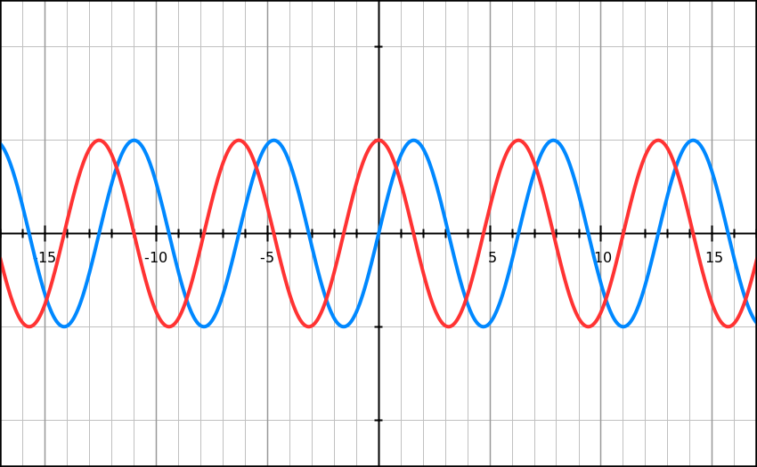

*\*The blue line is and the red line is . Notice that the red graph is just the blue graph shifted a bit to the left.*

Our equations have the same basic format or . So what do all these letters represent?

*x* is the position of the mass as it oscillates back and forth. And *t* is the time. For a simple function it just means as the time changes the position follows the same pattern of a sine graph: up and down, up and down (or in this case: left and right, left and right).

But what about the *A* and the *f* ? Those can be more complicated. The graphs that follow show what those represent:

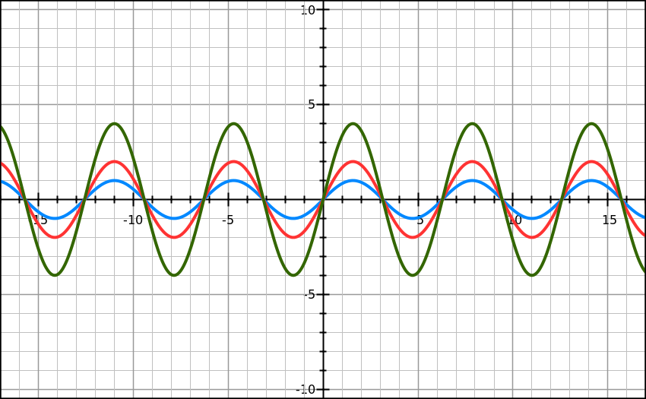

*\*The blue line is , the red line is , and the green line is . Notice how increasing the coefficient in front of the sine function only changes the amplitude of the function. Therefore in , A is the amplitude.*

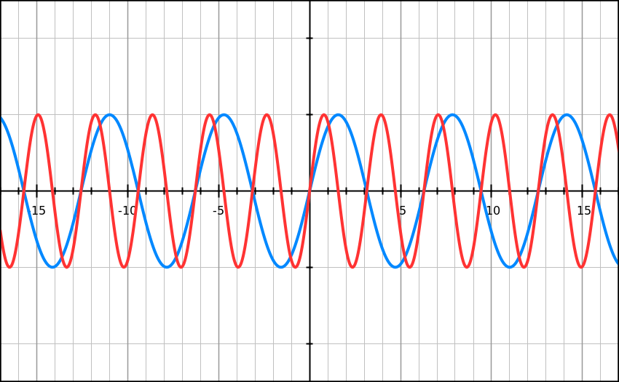

*\*The blue line is and the red line is . Notice how increasing the coefficient in front of the x changes how quickly the sine function repeats itself. Therefore in , f is the frequency.*

The period, by definition is the amount of time it takes something to repeat its motion. That’s the same as saying the amount of time it takes to accomplish of something. Frequency is how many repeats you get each second or how many ’s you get each second.

Therefore:

Remembering our definition of from before:

And finally, the period of a mass-spring oscillator: