What is the International Baccalaureate Program?
The IB Mission Statement The International Baccalaureate aims to develop inquiring, knowledgeable and caring young people who help to create a better and more peaceful world through intercultural understanding and respect. To this end the organization works with schools, governments and international organizations to develop challenging programs of international education and rigorous assessment. These programs encourage students across the world to become active, compassionate and lifelong learners who understand that other people, with their differences, can also be right.
The IB Learner Profile Each of the IB’s programs is committed to the development of students according to the IB learner profile. The profile aims to develop learners who are • Inquirers • Knowledgeable • Thinkers • Communicators • Principled • Open-minded • Caring • Risk-takers • Balanced • Reflective
The aim of all IB programs is to develop internationally minded people who recognize their common humanity and shared guardianship of the planet. Central to this aim is international-mindedness. International-mindedness is a multifaceted concept that captures a way of thinking, being and acting characterized by an openness to the world and a recognition of our deep interconnectedness to others. To be open to the world, we need to understand it. IB programs therefore provide students with opportunities for sustained inquiry into a range of local and global issues and ideas. This willingness to see beyond immediate situations and boundaries is essential as globalization and emerging technologies continue to blur traditional distinctions between the local, national and international. An IB education fosters international-mindedness by helping students reflect on their own perspective, culture and identities, as well as those of others. By engaging with diverse beliefs, values and experiences, and by learning to think and collaborate across cultures and disciplines, IB learners gain the understanding necessary to make progress towards a more peaceful world. An IB education further enhances the development of international-mindedness through multilingualism. All IB programs require students to study, or study in, more than one language. This is because we believe that communicating in more than one language helps students to appreciate that his or her own language, culture and world view are just one of many. In this way, it provides excellent opportunities to develop intercultural understanding and respect. International-mindedness is also encouraged through a focus on global engagement and meaningful service with the community. These elements challenge students to critically consider power and privilege, and to recognize that they hold this planet and its resources in trust for future generations. They also highlight the focus on action in all IB programs: a focus on moving beyond awareness and understanding to engagement, action and bringing about meaningful change to make a more peaceful and sustainable world for everyone.

The IB Curriculum
MYP (Middle Year Program) Students – this program is designed to prepare 9th & 10th grade students for the rigor of the IB programs during their 11th & 12th grade years. Students create a personal project, take at least one advanced level (honors) course, begin their coursework in world languages, and complete various service projects.
Full Diploma students must take courses in each of six subject areas:
• Group 1: Language A (the student’s native language) - Literature in English (HL only)
• Group 2: Language - French * Spanish * German
• Group 3: Individuals and Societies - History of the Americas (HL only) * Psychology (SL only)
• Group 4: Experimental Sciences - Biology * Physics * Chemistry * Environmental Systems and Societies * Sports and Exercise Sciences
• Group 5: Mathematics
• Group 6: Arts and Electives - Visual Arts * Film and Multimedia
Students must take three and not more than four subjects at the Higher Level. The remaining subjects are taken at the Standard Level. Each subject is graded on a scale of 1 (minimum) to 7 (maximum). Students must earn a minimum of 24 points to receive the Diploma. Twelve of those points must be earned in HL subjects, and the student must successfully complete the Extended Essay, Theory of Knowledge assessments and CAS projects to receive the Diploma. The Six Academic Subjects These are studied concurrently, and students are required to study all six academic areas. Higher level courses are offered over a minimum of 240 teaching hours; SL courses cover a minimum of 150 teaching hours. Students begin the Diploma Program in 11th grade.
IB Career Students must take a minimum of 2 IB courses, scoring at least a 3 on the graded scale. Students must also successfully complete a 2-year CTE program (with certification at the end of the program), the Personal and Professional Skills course, a Reflective Project, Language Portfolio and Service Hours.
Why become involved in the IB Program?
IB programs promote the development of schools that:
• Create educational opportunities that encourage healthy relationships, individual and shared
responsibility, and effective teamwork and collaboration.
• Help students make informed, reasoned, ethical judgments and develop the flexibility,
perseverance, and confidence they need in order to bring about meaningful change.
• Inspire students to ask questions, to pursue personal aspirations, to set challenging goals, and to
develop the persistence to achieve them.
• Encourage the creation of rich personal and cultural identities.
These educational outcomes are profoundly shaped by the relationships between teachers and students; teachers are intellectual leaders who can empower students to develop confidence and personal responsibility. Challenging learning environments help students to develop the imagination and motivation they need in order to meet their own needs and the needs of others. The IB Program emphasizes learning how to learn, helping students interact effectively with the learning environments they encounter, and encouraging them to value learning as an essential and integral part of their everyday lives.

Approaches to Teaching & Learning: Grounded in contemporary educational research, the IB’s six approaches to teaching and five approaches to learning guide and focus educators and students in IB World Schools. They play a crucial role in ensuring that the aspirations of an IB education become a reality in the classroom. The approaches are centered on a cycle of inquiry, action and reflection—an interplay of asking, doing and thinking—that informs the daily activities of teachers and learners. They also place a great deal of emphasis on relationships. This reflects the IB’s belief that educational outcomes are profoundly shaped by the relationships between teachers and students, and celebrates the many ways that people work together to construct meaning and make sense of the world.
Approaches to Teaching:
- Based on Inquiry
- Focused on conceptual understanding
- Developed in local and global contexts
- Focused on effective teamwork and collaboration
- Designed to remove barriers to learning
- Informed by assessment
Approaches to Learning:
- Thinking skills
- Research skills
- Communication skills
- Social skills
- Self-management skills

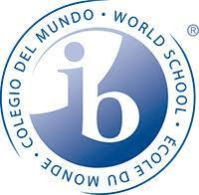
IB Courses offered at CHS

IB English 11
IB English 12
IB English Language and Literature

IB World Languages – Spanish, French, German

IB Film 1
IB Film 2
Career Areas of Study:
Agriculture
Culinary
Child Development
Marketing
Computer Science
Film/Multimedia
Graphic Design
Woods
Auto Tech
ROTC

IB Math Applications SL 1
IB Math Applications SL 2
IB Statistics
IB Calculus AB
IB Calculus BC
IB HL Mathematics

IB Biology 1
IB Biology 2
IB Chemistry 1
IB Chemistry 2
IB Environmental Systems and Societies
IB Sports, Exercise and Health Science
IB Physics

IB American/Arizona History
We All Are IB!!
IB History Higher Level
IB Psychology Standard Level

IB Personal and Professional Skills
IB Theory of Knowledge

International Baccalaureate (IB) | Advanced Placement (AP)
IB is a two-year program of study that includes courses in different fields. Students CAN take independent courses of study as well. | AP consists of independent courses of study.
IB is open to all students willing to challenge themselves with college-level coursework and willing to complete additional IB requirements. | Open to all students willing to challenge themselves with college-level coursework.
IB Diploma & Career candidates also take a Theory of Knowledge course(Diploma) or a Personal and Professional Skills course (Career) which include college-level writing projects | No additional requirements
IB scores are based on IB exams that are almost entirely written as well as in-class writing, projects and presentations that are scored internally and externally. | AP scores are based solely on a single-day exam that is generally 60% multiple choice and 40% essay.
Students enrolled in the IB program or in an IB course of study as certificate students may take IB exams and may earn college credit. | Any student may take an AP exam; specific courses are taught but are not required in order to take the IB exams. IB students may take AP exams.
IB exams are developed and scored by an international panel of trained examiners. Exams are administered locally and sent to the IB Organization examination headquarters in Wales for scoring. | AP exams are developed by a national development committee in conjunction with experts from Educational Testing Service (ETS). Exams are administered nationally and shipped to ETS for scoring.
IB teachers work as a team to support students and to connect the curriculum across disciplines and to promote world-wide relevancy for all coursework. | AP teachers work independently or within their own discipline to support students.
IB courses move at a different pace, many over a two-year period of time, to allow for in-depth research, inquiry and analysis. | AP courses move at a rapid pace surveying a broad spectrum of a particular discipline.
IB seeks to create a cohort or peer group around academics | AP students may form peer groups within individual classes or disciplines, but this is not a goal of the program.
More divergent – Asking “WHY?” more than “WHAT?” | More convergent – Asks ‘WHAT?” more than “WHY?”
Emphasis process and integration of content across content and content areas. | Content is discreet to each subject with little to no crossover.
IB student MAY ALSO sit for AP exams. | AP students MAY NOT sit for IB exams.
Successful IB candidates receive an IB Diploma for completing full programs or an IB certificate for individual IB courses taken. | AP recognizes high achievement on AP exams through the AP Scholars Program.
College credit is awarded at the discretion of each individual college. | College credit is awarded at the discretion of each individual college.

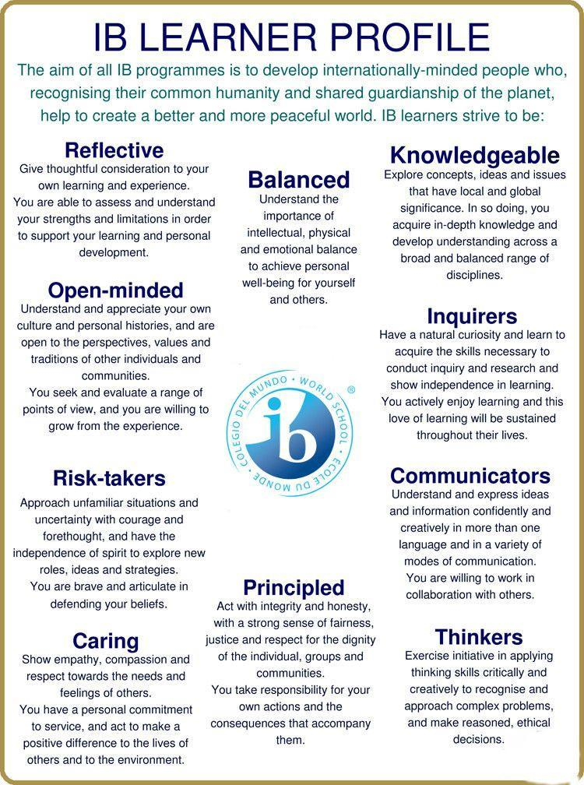

The IB learner profile brings to life the aspirations of a community of IB World Schools dedicated to student centered education.

The Chandler High School IB program prides itself on serving the global community as well as our State and local community. We work to give back as seen with the state-wide adopted ‘IB Day of Service’. Students in the IB program are also guaranteed a smaller, more supportive high school experience, engaging in school activities, support groups, community service, etc…
Below are some of the visual reflections of how we have been able to bind our IB students

