Annual Transportation Request Information in Infinite Campus Parent Portal
The CUSD Transportation Dept will begin collecting data from parents on whether or not they will be utilizing our bussing to transport their students to/from school (if eligible) starting for the 2023-24 school year.

New to CUSD families will answer the transportation question on their Online Registration Application.
Existing CUSD families will complete the application that’s explained in this document.

*Existing Families*
- Login to Parent Portal
- Click on “More” from the left-hand side bar.
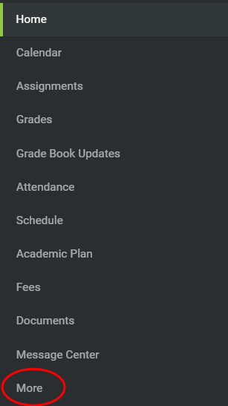

- Click on “Transportation Request” under the Quick Links section.
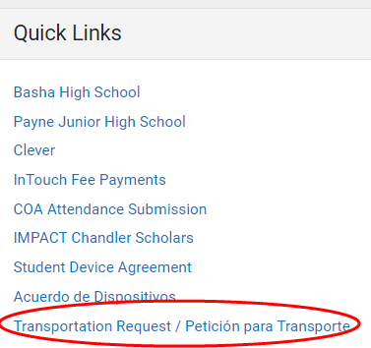

- Select English or Spanish.
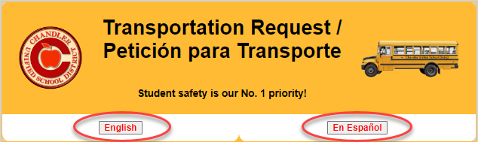

- Read through the Transportation information, click the box to acknowledge the information, and click “Click here to proceed to the Transportation Request”.
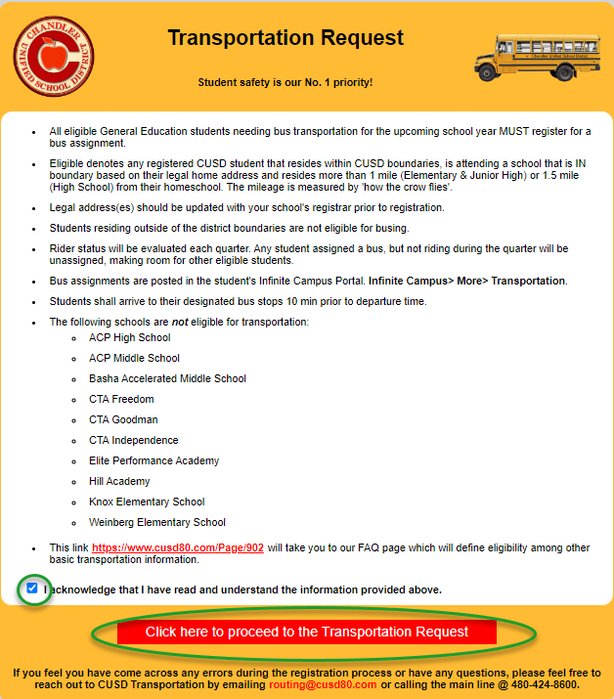

- You will be taken to a screen similar to the one shown below that will list your student(s), their eligibility status, and a yes or no button to select whether you will be utilizing the bussing system.
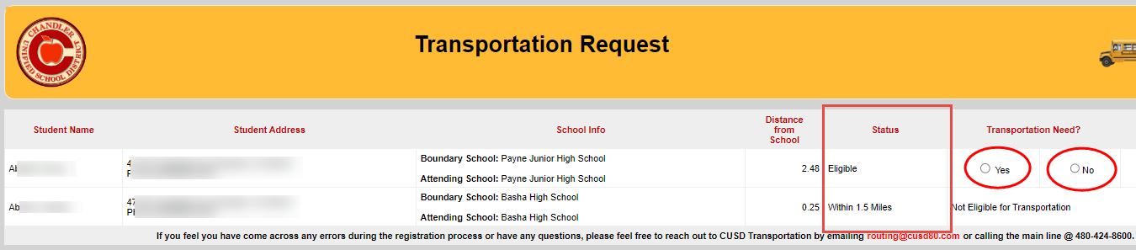

- Select “Submit”
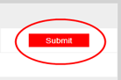

Once submitted, you will not be able to change your answer. If you want to change your selection, you’ll need to contact the Transportation department at routing@cusd80.com or 480-424-8600.

