Structure Words
What |   This Photo by Unknown Author is licensed under CC BY-NC | What or who is the picture/story about?
Size | 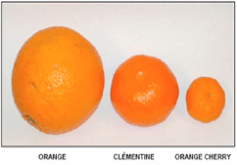  This Photo by Unknown Author is licensed under CC BY-SA | What Is the size of the things in the picture/story?  There is a ______(size) ________ (object) in the picture/story.
Color | 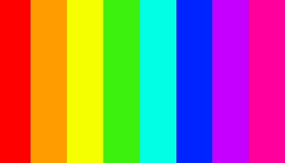 | What colors do you see in the picture or in your mental movie of what you read?  The __________(object) is _____(color).
Number | 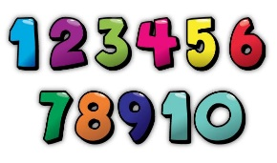 | How many of each item is in the picture/story?  There are __________(number) of _____(item).
Shape | 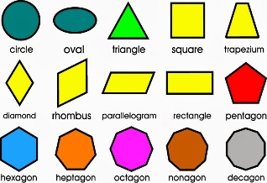 | What shapes are in the picture/story?  The _______(item) is the shape of a ______(shape)
Where | 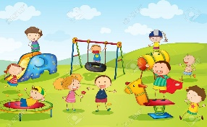  This Photo by Unknown Author is licensed under CC BY-NC-ND | Where is the picture/story happening?  Is it inside or outside?  What place are they at?
Movement | 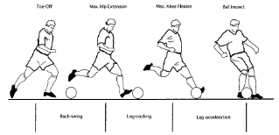 | What are the characters or objects doing?  What is moving in the picture/story?
Background | 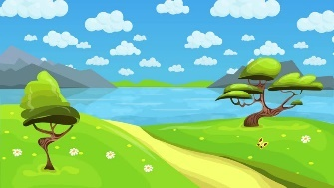 | What is happening in the background of the story/picture?
Perspective |  | Who is telling the story?  Are they part of the story or an outside observer (first or third person point of view?)  What was the authors purpose? (persuade, entertain, inform)
Sound |  | What sounds might you hear?
Mood | 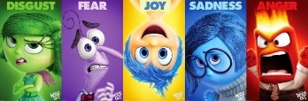 | What is the character feeling?  Does it change as the story goes on?
When | 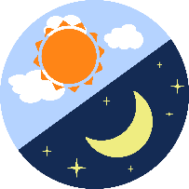 | What time is the picture/story taking place?  Is it day or night?  Is it the past, present, or future?  What season or time of year is it?

