THE FOOT AND ANKLE REVIEW

1. How many bones are in the Foot/Ankle?
2. How many Phalanges are there?
3. How many Metatarsals are there?
4. How many Tarsals are there?
5. How many cuneiforms are there?
6. What is the First Toe or Great Toe called?
7. What metatarsal is most commonly fractured?
8. Which bone is the main weight bearing of the Lower Leg?
9. Which bone is the main weight bearing bone of the Foot?
10. What is the most commonly sprained Lateral Ankle Ligament? (Abbreviations are fine)
11. What are the Medial Ankle Ligaments called?
12. What motion or action does the Tibialis Anterior perform on the Foot?
13. What are the 2 muscles of the calf?
14. What motion or action do the Gastrocnemius and Soleus perform on the Foot?
15. What motion or action does the Extensor Hallucis Longus/Brevis perform?
16. What motion or action does the Flexor Hallucis Lomgus/Brevis perform?
17. What motion or action does the Extensor Digitorum perform?
18. What motion or action does the Flexor Digitorum perform?
19. What are orthotics supposed to do for your foot/ankle?

23) Which direction does your ankle have to go to suffer a Medial Ankle Sprain?

Inversion Eversion

24) Which direction does your ankle have to go to suffer a Lateral Ankle Sprain?

Inversion Eversion

25) What is the proper treatment for a 1st degree ankle sprain?

26) What is the proper treatment for a 3rd degree ankle sprain?

27) What is Turf Toe?

28) What are 2 special tests for the ankle?

29) What does the Thompson Test, test for?

30) What condition can happen from wearing shoes that are too small?

31) What is the term given for anterior lower leg pain?

21,22) Label the following pictures accordingly as Pes Cavus or Pes Planus:

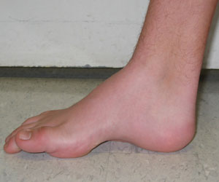

[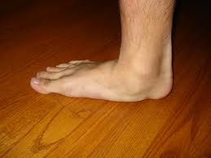](http://www.google.com/imgres?q=High+Arches&hl=en&biw=1280&bih=523&gbv=2&tbm=isch&tbnid=wzmsc6Cn2YMXbM:&imgrefurl=http://www.lookfordiagnosis.com/mesh_info.php?term=Flatfoot&lang=1&docid=mrnEHM7_Z9D2iM&imgurl=http://www.advancedfoottexas.com/wp-content/uploads/2010/06/flatfoot2.jpg&w=1632&h=1224&ei=6_KZT8WjKMKK2gXz8cT9Dg&zoom=1&iact=hc&vpx=735&vpy=3&dur=5406&hovh=194&hovw=259&tx=142&ty=127&sig=105690725573369582614&page=4&tbnh=155&tbnw=222&start=47&ndsp=15&ved=1t:429,r:3,s:47,i:237)

32-46) Label the Following:

Tibia Fibula Talus Calcaneous Cuneiforms

Metatarsals Phalanges 1st Metatarsal 5th Metatarsal Hallux

Navicular Cuboid Tarsals

