PERRY PADDLEBOARDING CLUB  PADDLE LOCATIONS:  ARIZONA  SAGUARO LAKE  Butcher Jones Recreation Area  LOWER SALT RIVER  Granite Reef Recreation Area  TEMPE TOWN LAKE  Marina Boat Launch  LAKE PLEASANT  Pleasant Harbor Marina  CANYON LAKE  Canyon Lake Marina  Acacia Recreation Area  Bartlett Lake  Bartlett Lake Marina  Rattlesnake Cove  SALT RIVER RUN  Pebble Beach to Phon D Sutton  Recreation Areas | PERRY PADDLEBOARDING CLUB    PADDLES UP!  RULES AND WATER SAFETY INFORMATION  Students will sign a permission slip/release form for outside of school events stating:  I WILL:  - Be an active member of the club.  - Be able to swim in water 3’ and deeper.  - Have a paddle buddy on the water.  - Always wear a PFD- Personal Flotation device.  - Provide my own transportation to and from off-campus events.  - Follow all rules of water safety to safely navigate on the water. | PERRY PADDLEBOARDING CLUB  C-303  ThAT’s WHAT’S SUP!  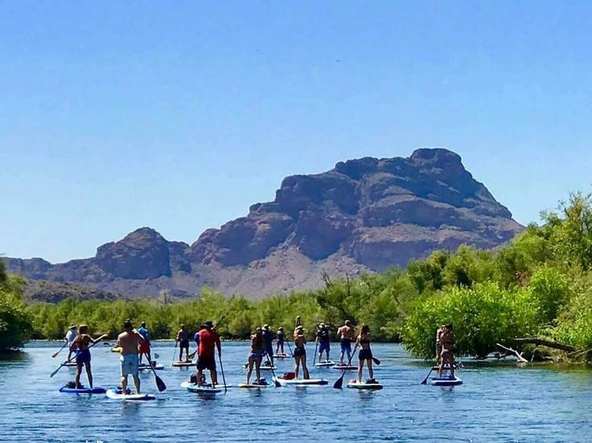
POSSIBLE WEEKEND PADDLES:  Willow Springs Lake, Watson Lake  You may bring your own equipment, otherwise SUP, paddles & PFD are available to rent  Tonto Pass: https://www.fs.usda.gov/detail/tonto/passes-permits/recreation | COST  The club is FREE to join. Off-campus Paddleboarding events will require a paddleboard (SUP), paddle and PFD. If parking a vehicle, in some locations a Tonto National Forest Pass permit or the America the Beautiful National Park Pass must be displayed. Some locations may require an entry fee at the gate. | - MEETINGS: ODD BLOCK DAY CONFERENCE  August 16 & 30, September 13 & 27, October 19, November 8 & 29, December 13 2022  - ONCE A MONTH PADDLES ON AZ LAKES & RIVERS

