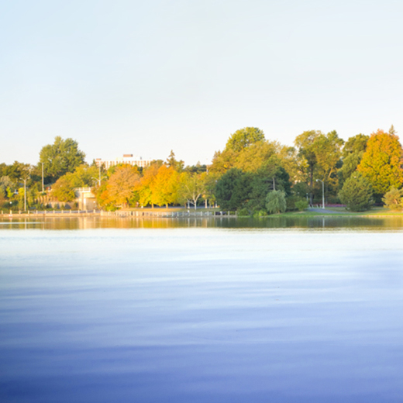  [Type a caption for your photo]  TRADITIONS AND CELEBRATIONS  - Give names and dates of two holidays other than Christmas that your country celebrates  - Other Traditions your country may have  - Add Picture: To replace a photo above or the logo with your own, just right-click it and then click Change Picture. |  |  | CLIMATE  - What is the Average Temperature year round  - Do different parts of the country have different climates:  - What is the average rain or snowfall? |  |  | Catchy tagline or Slogan  [Cite your source here.]  Country Name  - Your Name  Teacher’s Name

  TOURISM  What is the country best known for?  - Name 2-3 places people visity in your country. Explain what they are and why people want to visit them.  - Add pictures  (And be sure to pick photos that show off the countries tourism. Pictures should always dress to impress.) |  |  | FOODS  What is the country best known for?  - List 2-3 foods that are native to your country. Describe the dishes  - Include Pictures of these foods  “Don’t be shy! Show them how fabulous you are! This is a great spot for a glowing testimonial of foods from your country. Find a great review or quote to place here..”  Add more text here about food  .  |  |  | [Type a caption for your photo]  PLANTS AND ANIMALS  What type of plants and animals are found (desert, forest, swamp, etc.)  - List 2 animals and 2 plants that are native to your country.  - Explain what they are and why you chose them.  - Add pictures of the animals/plants you chose.

