Ecology Quiz Review

1. List and explain what characteristics make something alive.
2. Using the graph below, figure out the information needed to complete the following table.

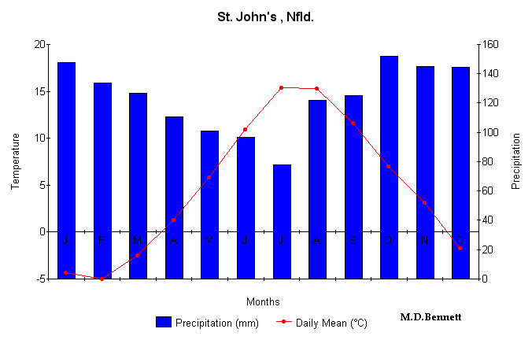

|  |  |  |  |  |  |  |  |  |  |  |  |  |
| --- | --- | --- | --- | --- | --- | --- | --- | --- | --- | --- | --- | --- |
|  | Jan. | Feb. | Mar. | Apr. | May | June | July | Aug. | Sept. | Oct. | Nov. | Dec. |
| Average  Monthly  Temperature  (deg. C) |  |  |  |  |  |  |  |  |  |  |  |  |
| Average  Monthly  Precipitation  (mm) |  |  |  |  |  |  |  |  |  |  |  |  |

3.What is biodiversity?

4.Why is biodiversity important?

5.What factors determine the conditions of a biome? List some specific examples.

6.Describe and provide an example for each of the following:

* Mutualism
* Commensalism
* Parasitism
* Predator-prey

7.What is symbiosis?

8.What is a niche? Give an example

9. What is a food web? What is the difference between a food web and a food chain?

10.Draw an energy pyramid, list the producers and different consumers. Indicate how much energy is transferred up each trophic level?

11. What are biotic and abiotic factors? How do abiotic factors affect biotic factors?