**ECA Fee Payment and Tax Credit Donation Instructions**

1. Upon clicking the InTouch Fee Payments link in Infinite Campus, you will see a screen like the one below listing all of your children and yourself. Click on the student for which you want to make a fee payment or donation.

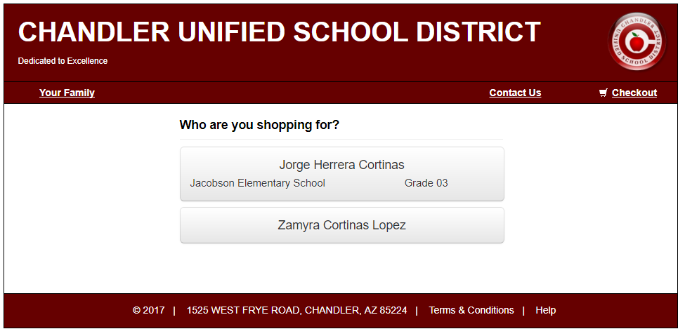

Parent’s Name



1. If your student has any outstanding fines or fees you will see a red notification window with the amount of unpaid fines/fees. Click the red “View” button to see the list of fines/fees to make a payment.

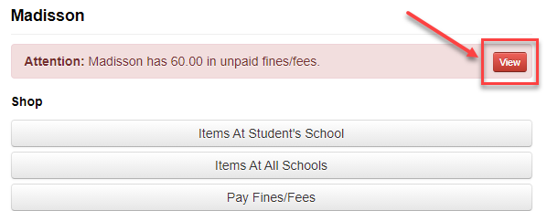

1. Any current fines or fees on your student’s account will appear. If you want to pay the fees in full, click the “Pay” checkbox next to each fine or fee. If you want to make a partial payment, enter the amount you would like to pay and then click the “Pay” checkbox. Please note, all ECA participation fees are non-refundable.

Click the blue “Pay Selected Fines/Fees” when finished.

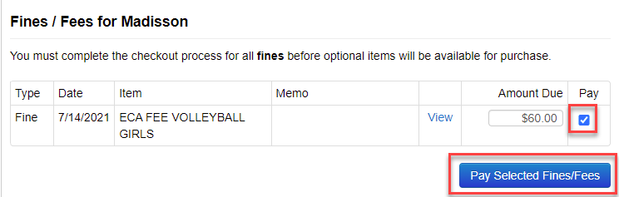

1. You’ll notice that the item is now in your shopping cart on the upper left-hand corner of the screen. Now, that the fee has been added to your cart you can make a tax credit donation by clicking the “Continue Shopping” button. Otherwise, you can click the blue “Checkout” button to complete your payment (skip to step 8 if you do not want to make a tax credit donation).

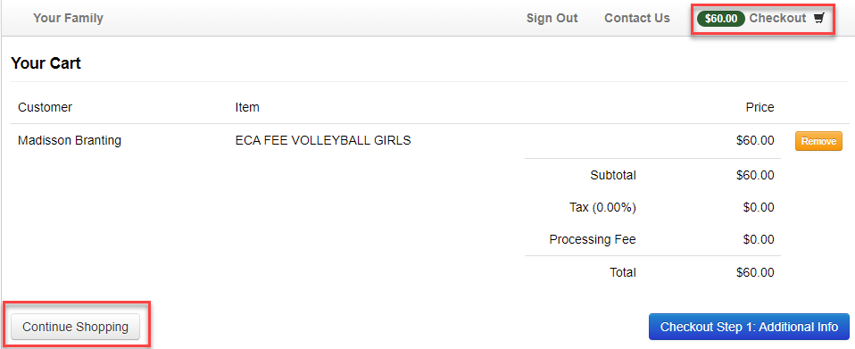



1. Select the link for “Tax Credit Donations” from the available options.
2. 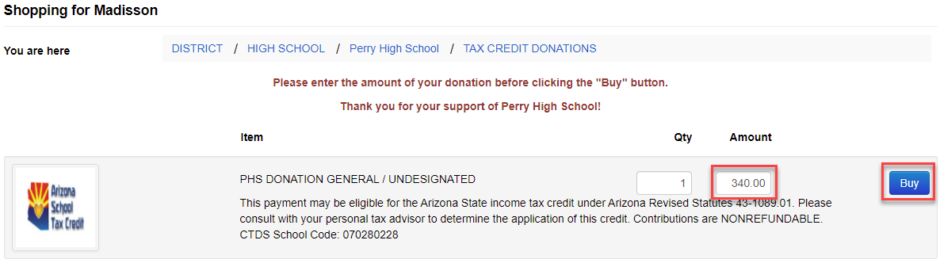Select the extra-curricular activity you would like to support with your tax credit donation and enter the dollar amount of your donation. Click the blue “Buy” button to add the item to your shopping cart.

*A tax credit is a dollar-for-dollar reduction in the actual tax owed. Qualifying contributions (up to $200 for individuals and up to $400 for married couples filling jointly) can be claimed on personal Arizona income taxes to reduce the amount owed or increase the refund amount.*

Please note: If a tax credit donation is made and other ECA fees are assigned to your student’s account in the future, tax credit donations can only be applied to tax credit eligible fee payments within the same school year. Class fees, instrument rental fees, lost/damaged book fines, event tickets, ID replacement fees and PE uniforms fees are not tax-credit eligible.

1. Click the shopping cart “Checkout” link when you are ready to pay.



1. The list of items in your cart will appear. Click the “Checkout Step 1: Additional Info” button to proceed.

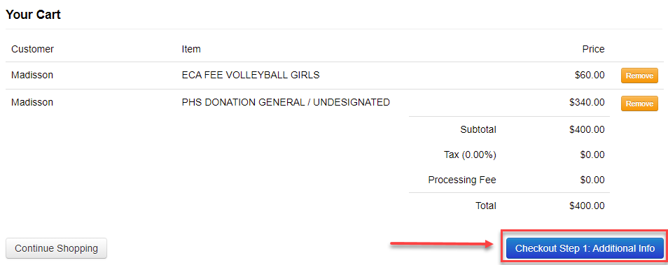

1. On the next screen you will be required to enter additional information for any tax credit eligible items. The information you input on this screen will be used on your official tax credit receipt. Once the information is entered, click the blue “Checkout Step 2: Payment” button.

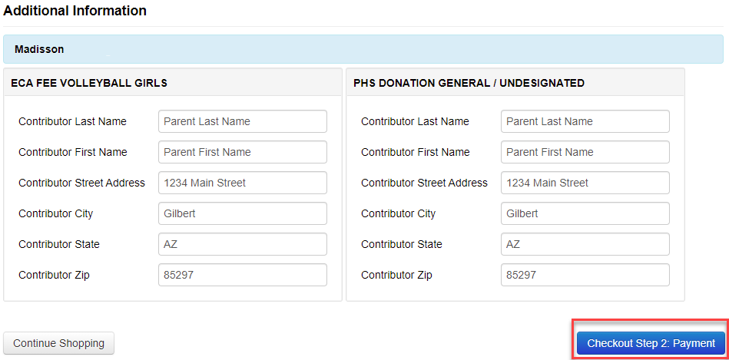

1. Enter the information in the required fields and select the blue “Pay Now” button when complete.

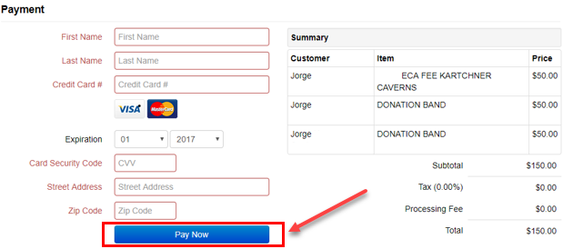

**Thank you for your support!**