** Chandler Unified School District**

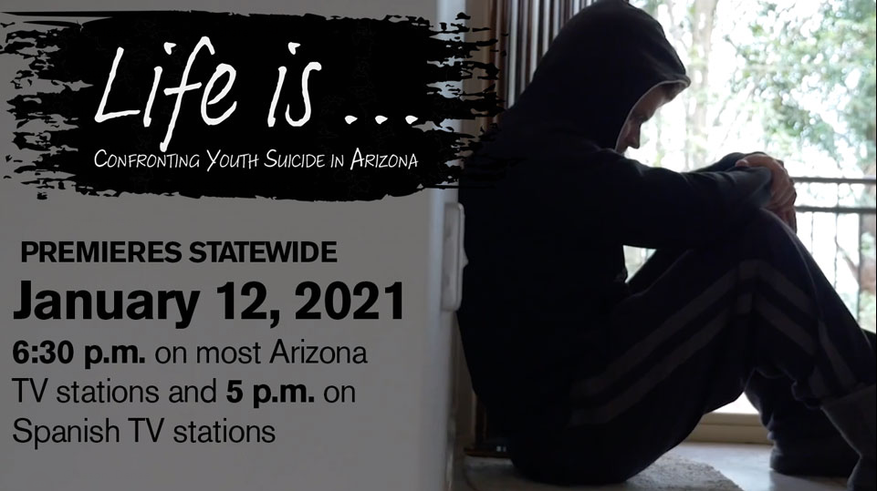  
  
CUSD families, we wanted you to be aware that several TV stations across Arizona are joining together tomorrow in an effort to combat the growing epidemic of youth suicide. In partnership with the Walter Cronkite School of Journalism and Mass Communication at ASU, 25+ TV stations will air a 30-minute, commercial free, student produced documentary about youth suicide in Arizona and what can be done to stop it.  To read more about the production please see the following link: <https://cronkite.asu.edu/news-and-events/news/arizona-broadcasters-simulcast-cronkite-documentary-youth-suicide-arizona>

**\*According to the CDC the leading cause of death for 10-14 year olds in the state of Arizona is suicide. This film is appropriate for 10-14 y/o if watched with parents/caregivers otherwise, 12 y/o is the appropriate age.**

Below is additional information and resources to support your student.

**EMERGENCY or IMMEDIATE HELP:** 9-1-1

**National Suicide Hotline:** 1-800-273-TALK (8255)   
**Crisis Text Line**: Text HELLO to 741-741

**Teen Lifeline:** (602) 248-TEEN (8336) 24/7 Call  
Text Available 12-9 PM M-F and 3-9 PM Weekends  
**Maricopa Crisis Line**: (602) 222-9444

**Safe Domestic Violence Services:** (480)-890-3039 or text LOVEIS to 22522

**Additional Information**

Suicide Warning Signs

* Threatening to hurt or kill oneself or talking about wanting to hurt or kill oneself
* Looking for ways to kill oneself by seeking access to firearms, available pills, or other means
* Talking or writing about death, dying, or suicide
* Feeling hopeless
* Feeling rage or seeking revenge
* Talking about being a burden to others
* Withdrawing or feeling isolated
* Acting recklessly or engaging in risky activities- seemingly without thinking
* Feeling trapped
* Increasing alcohol or drug use
* Withdrawing from friends, family, and society
* Feeling anxious, agitated, unable to sleep or sleeping all the time
* Experiencing dramatic mood swings
* Having no sense of purpose in life

**Things to remember**

* A suicide attempt is usually the last in a series of pleas for help. Any threat of suicide must be taken seriously.
* Most people who attempt suicide talk about it (post or write about it) before they take action
* A suicidal person does not usually intend to die, but it may be a plea for help. Recognition of the threat, and response to the person, is the best prevention strategy.
* School Counselors and Social Workers are available to provide support. Please contact your school for more assistance.

**Talking to your child** (Information obtained from Mind Wise- Signs of Suicide curriculum)  
Take some time to start a conversation about mental health. This can be tough for families as often in our society, mental health isn’t discussed openly like physical health. Feelings of depression or anxiety are often hidden because youth are confused, embarrassed, or ashamed. You can help protect your child and their friends by talking to them.

* Ask open-ended questions. Let your child steer the conversation to what they want to talk about.
* Don’t rush to solve their problems. Instead, ask what they think would help a situation.
* Be available and make sure your child knows it. “I'm around if you want to talk later” may help.
* Try talking on a walk. The relaxed atmosphere makes it easier for some kids to open up.
* It’s ok to ask the question, “Are you having thoughts of suicide?”

For more information on how to talk to your teen about difficult topics, please see our parent presentation archives. <https://www.cusd80.com/Domain/10528>

For more training on suicide or mental health see, our evidence based free courses. <https://www.cusd80.com/Domain/10528>