**MRS. SPENGLER**



Language Arts

## Payne Junior High School

[spengler.lindsie@cusd80.com](mailto:spengler.lindsie@cusd80.com)

480-224-2476

**Welcome to 8th Grade**

I'm excited to have you in my class and I'm even more excited to see all that you will accomplish this year. We will read (a lot), write (a lot), and talk (a lot). Parts of this course may be difficult to you, however with effort you will be successful. My job as your teacher is to provide you with the tools necessary to grow and succeed. Your job as the student is to maintain an open mind and come to each class eager to learn and challenge yourself.



**Virtual Learning Overview**

Assignments will be graded and

added to Infinite Campus weekly.

Material and instruction will occur

daily.

Participation in Google Classroom

is required.

Instruction will be both synchronous

and asynchronous.

Office hours will be available by

appointment for tutoring.

1. Have respect

**Expectations**

1. Come to class prepared
2. Be ready to participate
3. Be honest
4. Try your best & hardest
5. Challenge yourself
6. Never say "I don't know"

WHAT WE READ...

Literary Novels, Historical Fiction, Short Stories, Poems, Non-Fiction Texts, and Biographies

# WHAT WE WRITE...

Extended paragraphs, Literary Analysis, Argumentative Essays, Persuasive Letters, Narratives, MLA Citations, and proper grammar conventions

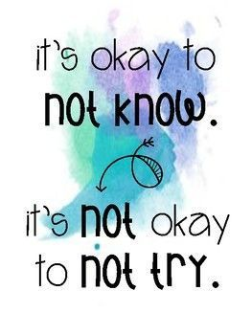

### Tests & Quizzes - 60%

Grades

Will include projects and any other assessment that demonstrates mastery of a skill, objective, or standard

**Classwork - 40%** Bell work, assignments, discussions, or activities

completed in class. These may be individual or group based.

**Due Dates**

Work will be due **24-48 hours** after being assigned.

Any technology or assignment issues should be communicated with me prior to the due date.

Where’s My Class?

* All materials and assignments can be found in Google Classroom.
* Assignments will be organized by week and labeled by day.
* All assignments will be uploaded with a clearly stated due date.

IF YOU NEED HELP . . .

Talk to me! My job is to help prepare you for your next steps in life. One of the most important skills you will use in life is **self-advocacy.**

If you need anything, all you need to do is talk to me.

1. Email me!
2. I’m in my classroom M-F from 8:30am to

4:30pm.

1. Tutoring is available before and after

school by appointment.

**T E C H N O L O G Y**

### It will fail. I get it. Make sure you have a backup. Make sure you are not procrastinating. Make sure you are communicating with me.

### If you are having technology issues please contact me BEFORE the assignment is due.

Retakes & Extra Credit

Retakes of assessments and classwork is at the teacher's discretion.

Extra credit is not offered for this course.

**Parents:** Please email or call me with questions or concerns (or anything else), but please encourage your son/daughter to approach me first so they can work on their self-advocacy skills.

Please review my syllabus with your parents. If you have any questions or concerns please let me know.

Student Name (Printed) Parent/Guardian Signature

